The Candidates for Local Office – 2016

Article 1: Candidates

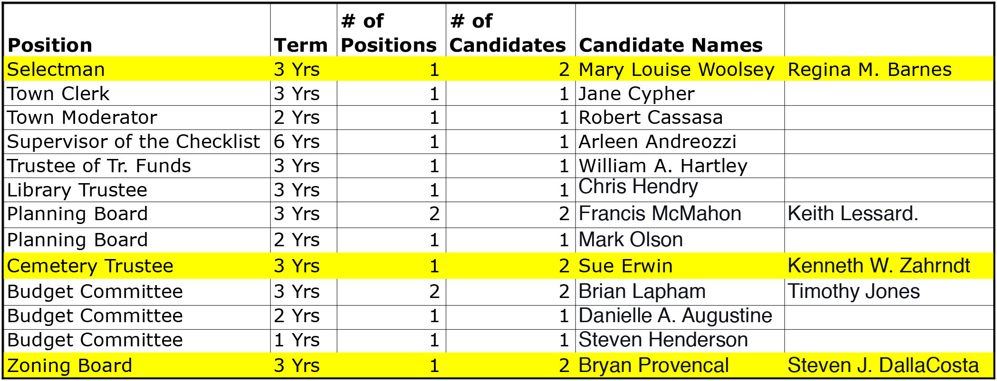

Zoning Articles
Article 2: Zoning – Clarify Language re: Non-Conforming Use Ordinance
Are you in favor of the adoption of Amendment No. 1 as proposed by the Planning Board for the Hampton Zoning Ordinance as follows?
Amend Article 1 – General, Sections 1.2 and 1.3 to clarify and improve the existing language regarding the reconstruction of non-conforming uses, and also the expansion, alteration, and abandonment of nonconforming uses.
Click here to see what the Zoning Ordinance would look like if this Article passes:
Art 2 Amend 1_Non-Conforming Uses
What it means: This article is intended to clarify the Zoning Ordinance regarding non-conforming uses in the two referenced sections. It does not change the intent or meaning of the Ordinance.
Those in favor of Article 2 say: No one spoke in favor of this Article at the Deliberative Session.
Those against Article 2 say: No one spoke against this Article at the Deliberative Session.

Article 3: Zoning – Require Planning Board Approval for All Change of Use Plans
Are you in favor of the adoption of Amendment No. 2 as proposed by the Planning Board for the Hampton Zoning Ordinance as follows?
Amend Article 1 – General, Section 1.6 to modify the definition of “Use Change,” requiring Planning Board approval in all instances where the current and proposed uses are dissimilar, referencing the previously adopted Use Change approval requirements of the Town Center District, and clarifying that Use Changes are subject to Site Plan and Subdivision approval (when applicable).
Click here to see what the Zoning Ordinance would look like if this Article passes:
Art-3-Amend-2_Section-1.6-Definitions-Use-Change.pdf
What it means: This article updates and expands the definition of “Use Change” by including the circumstances under which Planning Board approval is required, and by including the approval requirements for Change of Use in the Town Center District. This article does not change the existing Use Change approval requirements.
Those in favor say: No one spoke in favor of this Article at the Deliberative Session.
Those against say: No one spoke against this Article at the Deliberative Session.

Article 4: Zoning – Include Vernal Pools in List of Protected Wetlands Areas
Are you in favor of the adoption of Amendment No. 3 as proposed by the Planning Board for the Hampton Zoning Ordinance as follows?
Amend Article II – Districts, Section 2.3.1 Purposes to include vernal pools in the list of areas protected by the Wetland Conservation District.
Amend Article II – Districts, Section 2.3.2 B Definitions – “Inland Wetlands” to add examples of inland wetlands such as non-tidal portions of ponds, rivers and streams.
Click here to see what the Zoning Ordinance would look like if this Article passes:
Art-4-Amend-3_Purpose-and-Definition-Clarification.pdf
What it means: This article adds ‘vernal pools’ and examples of types of inland wetlands to more completely describe the areas already protected within the Town’s Wetland Conservation District.
Those in favor say: No one spoke in favor of this Article at the Deliberative Session.
Those against say: No one spoke against this Article at Deliberative Session.

Article 5: Zoning – Create a 100 foot Buffer for 1st through 4th Order Streams
Are you in favor of the adoption of Amendment No. 4 as proposed by the Planning Board for the Hampton Zoning Ordinance as follows?
Amend Article II – Districts, Section 2.3.2 E Definitions – “Buffer” to creat a 100’ buffer for a specified list of select 1st throuigh 4th order streams and rivers (Ash Brook, Drakes River, Little River, Nilus Brook, Old River, Taylor River, and Winnicut River).
Amend Article II – Districts, Section 2.3.3 Permitted Uses to add a new section that covers the permitted uses within the 1st through 4th order streams and their buffers.
Amend Article II – Districts, Section 2.3.4 Use Restrictions and Prohibited Uses (B, D, and F) to include appropriate references and clarifications with regard to the 1st through 4thorder streams and its 100’ buffer.
Amend Article II – Districts, Appendix to include a reference to the accepted scientific paper that established stream order.
Click here to see what the Zoning Ordinance would look like if this Article passes:
Art 5 Amend 4_1st through 4th Order Streams
What it means: These changes reference a new, graduated 100’ wetlands buffer only on the specific streams and rivers included in the article, describe the uses in each 25’ section of the 100’, and include language that adds the new buffer to the existing format of the Ordinances. See explanatory graphic here.
Those in favor say: The implementation of this additional, graduated buffer is needed to protect our primary fresh water streams and rivers closer to their sources.
Those against say: No one spoke against this Article at the Deliberative Session.

Article 6: Zoning – No Permanent Adverse Impacts to the Wetlands Conservation District
Are you in favor of the adoption of Amendment No. 5 as proposed by the Planning Board for the Hampton Zoning Ordinance as follows?
Amend Article II – Districts, Section 2.3.7, Special Provisions (C1 and C2) to add a sentence to clarify that no proposed development within the contiguous area shall result in any permanent adverse impacts to the Wetlands Conservation District.
Click here to see what the Zoning Ordinance would look like if this Article passes:
Art-6-Amend-5_Contiguous-Area.pdf
What it means: This warrant article makes it clear that development planned in the contiguous area of a parcel cannot include any permanent impacts to the Town’s wetlands, to poorly and very poorly drained soils, or to their buffers.
Those in favor say: No one spoke in favor of this article at the Deliberative Session.
Those against say: No one spoke against this article at the Deliberative Session.

Article 7: Zoning – Aquifer Protection District Ordinance
Are you in favor of the adoption of Amendment No. 6 as proposed by the Planning Board for the Hampton Zoning Ordinance as follows?
Amend Article II – Districts, Section 2.5 (Aquifer Protection District Ordinance) to add definitions for “Impervious Surface,” “Low Impact Development,” and “Sanitary Protective Radius;” to provide for review of reports involving zone designation by the Aquarion Water Company or its successor; to modify the Use Regulations as they pertain to Site Drainage, Prohibited Uses, Conditional Uses, and Non-Conforming Uses; to require notice to the Aquarion Water Company or its successor of any application within the Aquifer Protection District requiring a public hearing; and other general codification and consistency changes.
Click here to see what the Zoning Ordinance would look like if this Article passes:
Art 7 Amend 6_Section 2.5 Aquifer Protection District
What it means: These definitions and explanations is intended to add clarity and consistency to the Ordinance.
Those in favor say: No one spoke in favor of this article at the Deliberative Session.
Those against say: No one spoke against this article at the Deliberative Session.

Article 8: Zoning – Cross-Reference Existing Use Regulations in Other Sections of Ordinances
Are you in favor of the adoption of Amendment No. 7 as proposed by the Planning Board for the Hampton Zoning Ordinance as follows?
Amend Article III – Use Regulations to add notes cross-referencing the existing Use Regulations located in other sections of the Zoning Ordinance.
Click here to see what the Zoning Ordinance would look like if this Article passes:
Art 8 Amend 7_Article III Use Regulations
What it means: These ‘housekeeping’ changes is intended to make it easier to find references to the Use Regulations.
Those in favor say: No one spoke in favor of this article at the Deliberative Session.
Those against say: No one spoke against this article at the Deliberative Session.

Article 9: Zoning - Use Regulations re: Elderly Housing
Are you in favor of the adoption of Amendment No. 8 as proposed by the Planning Board for the Hampton Zoning Ordinance as follows?
Amend Article III – Use Regulations to add new Section 3.48 regarding Elderly Housing, which relocates the use table currently in Article XV and identifies applicable types of elderly housing.
Amend Article XV – Elderly Housing Standards to delete the use table (to be relocated under Article III) and to clarify the existing language.
Click here to see what the Zoning Ordinance would look like if this Article passes:
Art-9-Amend-8_Elderly-Housing-New-Section-3.48-and-Ameded-Article-XV-1.pdf
What it means: This establishes a new Section in the Ordinances pertaining to Elderly Housing and moves the use table to that Section.
Those in favor say: No one spoke in favor of this article at the Deliberative Session.
Those against say: No one spoke against this article at the Deliberative Session.

Article 10: Appropriate $2,000,000 for Waste Water Treatment
Here’s how Article 10 will read on your ballot:
Shall the Town of Hampton vote to raise and a appropriate the sum of $2,000,000.00 for the purpose of constructing the necessary upgrades to the Waste Water Treatment Facility Septic Receiving Station by purchasing and installing a Raptor Septic Acceptance Plant or its equivalent in order to process septic effluent containing materials that otherwise can a) clog pumps and valves, b) decrease the effectiveness of plant aeration, dewatering and filtering equipment, and c) decrease maintenance costs. Attached thereto will be a vehicle and equipment wash down facility that will accommodate all Town equipment and operate in accordance with the requirements of the Clean Water and Air Acts. Such appropriation includes improvements to the Recycled Wastewater Yard Piping to include the upgrading and replacement of the piping systems for the delivery of plant water to increase the efficiency of the Treatment Plant. Suc h appropriation includes safety improvements to the Sewer Plant valve pit, a hazardous work environment that employees must enter to operate the flow valves that control flow from the primary nd sludge thickener tanks. Included in the appropriation is the design, engineering, purchasing and installing an emergency generator to power the aeration blower system that is not now connected to emergency power. A loss of power means a loss of secondary treatment in the plant that the Town is required to maintain under law and its State and Federal permits.
Such sum to be raised by the issuance of municipal bonds or notes for a period not to exceed thirty (30) years under and in accordance with the Municipal Finance Act (RSA 33); and
To authorize the Board of Selectmen and the Town Treasurer to issue and negotiate such bonds or notes and to determine the rate of interest thereon; and
To authorize the Board of Selectmen to apply for, contract for, accept and expend any Federal, State or other available funds towards the projects in accordance with the terms and conditions under which they are received and to borrow in anticipation of the receipt of such and or the issuance of such bonds or notes as provided in the Municipal Finance Act (RSA33), as amended; and
To authorize participation in the State Revolving Fund (SRF) (RSA 486:14) established for the purpose, and to authorize the Board of Selectmen to apply for, accept, and expend such monies as they become available from the Federal and State Governments; and
To authorize the Board of Selectmen to implement such cost effective solutions as a re presented in the future that they deem to be in the best interests of the Town that may result in a lesser a mount of expenditure than is authorized by this warrant article; and
To authorize the Board of Selectmen to take any and all actions necessary to carry out the project in the best interests of the Town of Hampton? (3/5ths vote required)
What it means: This Article seeks to raise $2,000,000 via bonds or notes to upgrade the Wastewater Treatment Facility. Improvements include:
- Installation of a Septage Acceptance Plant and a New Grit Box
- New location for wash down area and connection to Septage Receiving
- Installation of new pumps, drives and pressure reducing system for plant recycle water
- Relocation of the suction intake pipe
- Emergency generator for the Plant Aeration System
Here is the breakout of the cost request, as provided at Deliberative Session:
• Septage Receiving Station: | $950,000
• Wash Down Facility: | $330,000
• Internal Yard Piping Improvements: | $ 80,000
• Safety Improvements Valve Pit: | $ 90,000
• Emergency Generator for Aeration Tanks: | $550,000
Those in favor say: The future quality of our water is at stake. This is an important effort that should be supported. All of the equipment being purchased with this bond has a life expectancy longer than the life of the bond (bond anticipated to be 30 years or less). The current equipment was installed in the 1940’s and 1950’s. The completed system will be safer for the employees and more environmentally friendly. Although the probability of needing emergency power for the aeration system is not great, if the town does need it and we do not have quick access, the problem and resulting DES fines could be significant.
Those against say: The cost of the individual items has not been presented. The Town needs to demonstrate why this equipment is needed. There is a low risk of keeping the system as is, and an undefined improvement in the risk level by investing in the new equipment. This is a bundle of 4 decisions, so we don’t know the cost and rationale for the individual items.
Fiscal Impact: The average Hampton home valued at $ 329,000 would bear an increased tax cost of $8.50 if this Article passes. Since it will be financed with long-term debt, it will have tax impacts into future years.
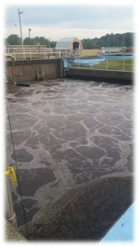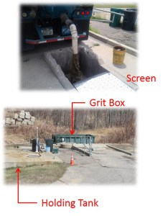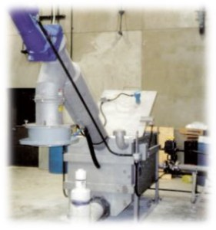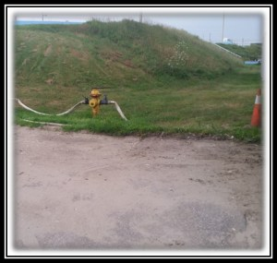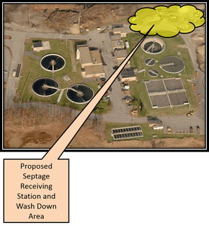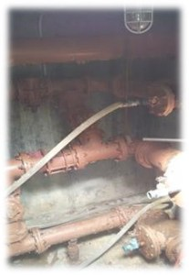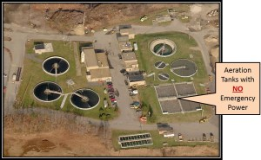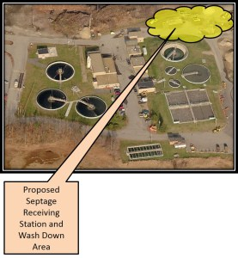

Town Sponsored Articles

Article 11: Town Budget
Shall the Town of Hampton vote to raise and appropriate as an operating budget, not including appropriations by special warrant articles and other appropriations voted separately, the amounts set forth on the budget posted with the warrant as amended by vote of the first session, for the purposes set forth therein, totaling $26,599,431.00? Should this article be defeated, the default budget shall be $26,528,092.00, which is the same as last year, with certain adjustments required by previous action of the Town of Hampton or by law or the governing body may hold one special meeting in accordance with RSA 40:13, X and XVI to take up the issue of a revised operating budget only. (Majority vote required).
What it means: The proposed budget of $26,599,431, if approved by voters, will be the Operating Budget for the fiscal year beginning January 2016. This represents less than one-tenth of 1% increase over 2015, which was a Default Budget
A “No” vote means: The Default Budget of $26,528,092 will be the Operating Budget for the fiscal year beginning January 2016. This is essentially the same as last year’s budget, which was a Default Budget. The Default Budget is defined as the prior year’s budget increased by contractual obligations, debt service and any Warrant Articles passed by the voters.
Those in favor of approving the proposed budget say: The Town’s Department heads did a good job of managing as best they could with the dollars provided last year, including cutting back where possible to make sure there was a reasonable amount for contingencies. A certain amount of excess for unforeseen events is prudent. Increases were absorbed; and line items were changed as needed, and as legally allowed. Any further cutback will affect the departments and what they can accomplish for the town.
Those against say: Even last year’s Default Budget had excesses. The Board of Selectmen moved money around without voter approval. New items were added to circumvent voter approval.
Fiscal Impact: The average Hampton home valued at $329,000 would bear an increased annual tax cost of $11.19 if this Article passes, and $2.63 if it were defeated. The difference is $8.56.
To calculate the effect on your property tax (for your specific property):
- Divide the Tax Assessor’s Valuation of your home by 1,000. (Example: for a $329,000 assessment, the number to use would be 329.) Use your latest tax bill, or go to: http://gis.vgsi.com/hamptonnh/Search.aspx Enter your street address to get your valuation.
- Multiply the result in #1 by .034 to get the tax impact of the proposed Operating Budget. Multiply the result in #1 by .008 to determine the tax impact of the Default Budget.

Articles 12-16 Ratify Bargaining Agreements
“What is a Cadillac Tax?”
Several discussions about the Collective Bargaining Agreements for the Town and also for the School Districts have mentioned a slightly higher rate of pay increase to make up for the fact that the Unions have agreed to “give backs” on health insurance to avoid the “Cadillac tax”. We’ve all heard the term, but what does it mean?
The tax will require employers to pay a 40 percent levy, starting in 2020*, on the amount by which the total costs of health plans exceeds an annual limit of $10,200 for an individual and $27,500 for a family. Although it is not effective for several years, the Town gave the negotiating teams a mandate to reduce the Health Insurance plans to avoid the penalty in the out years.
The Town is far from alone. A survey of Fortune 1000 companies by a top benefits consulting firm, found that the majority of companies indicated that the looming excise tax is having a “moderate” or “significant” influence on benefits decisions.
The Unions represented in Articles 14, 15 and 16 as well as the Teachers’ Union on the School District ballots have agreed to the give-backs and their contracts are for three years. The Fire Unions (Articles 12 and 13) have not yet come to terms with the issue. That’s why they have a one-year agreement, to give everyone time to sort out the health insurance terms.
* Thanks to a commenter for flagging that we had outdated information. The implementation date was changed from 2018 to 2020 last December. This post reflected the new information as of 3/4/16.
Article 12: One-year Bargaining Agreement with Fire Fighters
Shall the Town of Hampton vote to approve the cost items included in a one-year collective bargaining agreement reached between the Hampton Board of Selectman and the Hampton Fire Fighters Local 2664, which calls for the following increases in salaries and benefits at the current staffing levels:
2016 $42,906 (39 weeks) over 2015 level
2017 $14,302 (13 weeks) over 2015 level
And further to raise and appropriate the sum of $42,906 to fund the cost items related to the Hampton Firefighters Local 2664 salaries and benefits for 2016. Such sum represents the additional salaries and benefits (over the 2015 budget level) for the 2016 portion of the one year that is contained in an agreement between the Town of Hampton, by its Board of Selectmen, and the Firefighters Local 2664, pursuant to RSA 273-A. The estimated total cost of the agreement in salaries and benefits for the one-contract year is $57,209? (Majority vote required)
What it means: Town representatives have negotiated with the Firefighters union to negotiate a one-year agreement. The voters now need to either ratify the negotiated terms or reject the agreement. The dollars represent a 1.75% increase for the firefighters.
Those in favor say: This is a one-year maintenance agreement. The firefighters are always there for us and we should support them.
Those against say: No one spoke in opposition to this Article at the Deliberative Session.
Fiscal Impact: The average Hampton home valued at $329,000 would bear an increased tax cost of $4.94 for 2016, with an additional obligation of $1.65 in 2017.

Article 13: One-year Collective Bargaining Agreement with Fire Officers
Shall the Town of Hampton vote to approve the costs items included in a one-year collective bargaining agreement reached between the Hampton Board of Selectman and the Hampton Fire Officers Local 3017, which calls for the following increases in salaries and benefits at the current staffing levels:
2016 $17,751 (39 weeks) over 2015 level
2017 $ 5,917 (13 weeks) over 2015 level
And further to raise and appropriate the sum of $17,751 to fund the cost items related to the Hampton Fire Officers Local 3017 salaries and benefits for 2016. Such sum represents the additional salaries and benefits (over the 2015 budget level) for the 2016 portion of the one year that is contained in an agreement between the Town of Hampton, by its Board of Selectman and the Fire Officers Local 3017, pursuant to RSA 273-A. The estimated total cost of the agreement in salaries and benefits for the one-contract year is $23,668? (Majority vote required)
What it means: A yes vote approves the salary increases negotiated via the Collective Bargaining Agreement with the Fire Officers.
Those in favor say: Those who spoke at Deliberative Session expressed support for this and echoed the points made for the firefighters.
Those against say: No one spoke in opposition to this Article at the Deliberative Session.
Fiscal Impact: The average Hampton home valued at $329,000 would bear an increased tax cost of $1.97 if this Article passes.

Article 14: Three-year Collective Bargaining Agreement with Police Officers
Shall the Town of Hampton vote to approve the cost items included in a three-year collective bargaining agreement reached between the Hampton Board of Selectmen and the Hampton Police Association (Officers), which calls for the following increases in salaries and benefits at the current staffing levels:
2016 $ 72,616 (39 weeks) over 2015 level
2017 $110,583 (52 weeks) over 2016 level
2018 $114,445 (52 weeks) over 2017 level
2019 $ 26,353 (13 weeks) over 2018 level
And further to raise and appropriate the sum of $72,616 to fund the cost items related to the Police Association (Officers) salaries and benefits for 2016. Such sum re presents the additional salaries and benefits (over the 2015 budget level) for the 2016 portion of the three years that are contained in a collective bargaining agreement between the Town of Hampton by its Board of Selectmen and the Hampton Police Association (Officers), pursuant to N.H. RSA 273-A. The compounded, cumulative cost impact over the three contract years is estimated to be $660,273? (Majority vote required)
What it means: A yes vote approves the salary increases negotiated via the Collective Bargaining Agreement. This agreement covers 3 years starting in April of 2016. Of the three years (156 weeks) 39 weeks fall into 2016; 52 weeks into 2017; 52 weeks into 2018; and 13 weeks into 2019.
Those in favor say: This agreement represents 6 months of negotiations. The Town was able to move away from a health insurance plan that would have triggered a “Cadillac tax”. The pay increase is being partially offset by concessions by the union that allows for use of comp time as opposed to overtime pay. Because we have not passed contracts and wages have stagnated, we lost 4 part timers to the Manchester Police Department. We need to keep their pay competitive so that we are not spending the money on training replacements.
Those against say: No one spoke against this Article at Deliberative Session.
Fiscal Impact: The average Hampton home valued at $329,000 would bear an increased tax cost of $8.55 if this Article passes.

Article 15: Three-year Collective Bargaining Agreement with Police Sergeants
Shall the Town of Hampton vote to approve the cost items included in a three-year collective bargaining agreement reached between the Hampton Board of Selectmen and the Hampton Police Association (Sergeants), which calls for the following increases in salaries and benefits at the current staffing levels:
2016 $12,934 (39 weeks) over 2015 level
2017 $14,199 (52 weeks) over 2016 level
2018 $37,555 (52 weeks) over 2017 level
2019 $11,420 (13 weeks) over 2018 level
And further to raise and appropriate the sum of $12,934 to fund the cost items related to the Police Association (Sergeants) salaries and benefits for 2016. Such s um represents the additional salaries and benefits (over the 2015 budget level) for the 2016 portion of the three years that are contained in a collective bargaining agreement between the Town of Hampton by its Board of Selectmen and the Hampton Police Association (Sergeants), pursuant to N.H. RSA 273-A The compounded, cumulative cost impact over the three contract years is estimated to be $133,422? (Majority vote required)
What it means: The terms for the agreement with the Police Sergeants is the same as for the Police Officers. The dollars represent a 3% increase.
Those in favor say: We need to support our Police Sergeants. Half of the Officers down at the beach have less than 2 years experience and need good supervision.
Those against say: No one spoke against this Article at Deliberative Session.
Fiscal Impact: The average Hampton home valued at $329,000 would bear an increased tax cost of $1.65 if this Article passes.

Article 16: Three-year Collective Bargaining Agreement with Teamsters
Shall the Town of Hampton vote to approve the cost items included in a three-year collective bargaining agreement reached between the Hampton Board of Selectmen and the Teamsters Local 633, which calls for the following increases in salaries and benefits at the current staffing level:
2016 $41,259 (39 weeks) over 2015 level
2017 $58,004 (52 weeks) over 2016 level
2018 $47,205 (52 weeks) over 2017 level
2019 $ 9,809 (13 weeks) over 2018 level
And further to raise and appropriate the sum of $41,259 to fund the cost items related to the Teamsters Local 633 salaries and benefits for 2016. Such sum represents the additional salaries and benefits (over the 2015 budget level) for the first of the three years that are contained in a collective bargaining agreement between the Town of Hampton by its Board of Selectmen and the Teamsters Local 633 (Clerical, PW Foremen, PO Dispatchers), pursuant to N.H. RSA 273-A. The compounded, cumulative cost impact over the three contract years is estimated to be $336,855? (Majority vote required)
What it means: This is a negotiation that covers employees in several departments for a 3 year period. The dollars represent raises ranging from 2.5% to 3.3%.
Those in favor say: Similar to other negotiations, there were tradeoffs relating to health insurance coverage. This is a fair agreement for both the Town and the employees.
Those against say: No one spoke against this Article at Deliberative Session.
Fiscal Impact: The average Hampton home valued at $329,000 would bear an increased tax cost of $4.94 if this Article passes.

Article 17 – Repair of sidewalks
Shall the Town of Hampton vote to raise and appropriate the sum of $643,225 for improvements to streets consisting of paving overlays, adjustments to structures to permit paving, repairs and replacements to drainage, crack sealing, curbing installation and improvements to Town parking areas on the following streets, Landing Road south of State Route 101, Old Stage Road, Acorn Road and Driftwood Road, said appropriation to be offset by the State Highway Block G rant estimated to be $299,804. This shall be a non-lapsing appropriation per RSA 32:7, VI and shall not lapse until the projects are completed or by March 31, 2018, whichever occurs sooner? (Majority vote required)
What it means: The Town will raise the funds to do the specified work. A State Highway Block Grant will offset some of the expenses.
Those in favor say: The work is necessary due to several years of deterioration. As voters approve the funds, work is being completed on the roads that are most in need of repair. This process will continue each year until the quality of our roads is up to acceptable levels.
Those against say: No one spoke in opposition at the Deliberative Session.
Fiscal Impact: The average Hampton home valued at $329,000 would bear an increased tax cost of $40.47 if this Article passes.
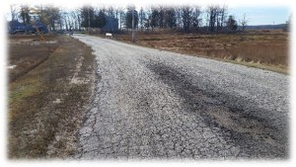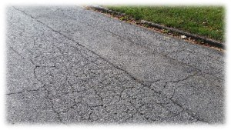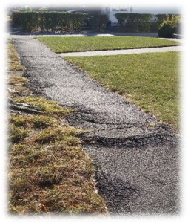

Article 18: Appropriate $353,000 for 3 DPW Trucks
Shall the Town of Hampton vote to raise and appropriate the sum of $353,000 for the purchase of the following replacement vehicles for the Department of Public Works; one (1) one-ton truck with dump body, plow and wing; two (2) 35,000 pound Gross Vehicle Weight dump trucks with plows and wings; the replaced vehicles to be traded in if deemed to be prudent by the Public Works Director, Town Manager and Board of Selectmen. This shall be a non-lapsing appropriation per RSA 32:7, VI and shall not lapse until these purchases are completed or by March 31, 2017, whichever is sooner? (Majority vote required)
What it means: The referenced equipment would be replaced if the voters approve.
Here is the breakout of costs, as provided at Deliberative Session:
• One Ton Dump Truck w/plow & wing: | $ 49,000
• 35,000 lbs Dump (Mack) w/plow & wing: | $152,000
• 35,000 lbs Dump (Mack) w/plow & wing: | $152,000
Those in favor say: This is not the first time that this equipment has been before the voters. In the ensuing time, there have been large expenditures to keep the 28-year old equipment road-worthy. There is significant under-carriage corrosion. We have had to fund expensive repairs. These trucks are the lead in the snow clearing fleet and it is getting harder to keep them in good working order.
Those against say: No one spoke in opposition at the Deliberative Session.
Fiscal Impact: The average Hampton home valued at $329,000 would bear an increased tax cost of $41.78 if this Article passes.

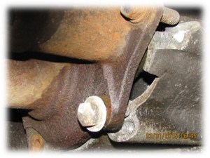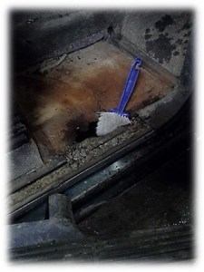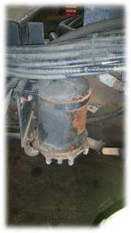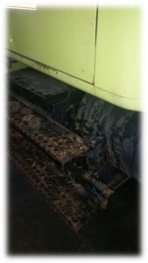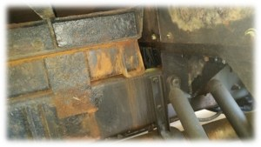

Article 19: Appropriate $300,000 for Road Improvement Capital Reserve Fund
Shall the Town of Hampton vote to raise and appropriate the sum of $300,000 to be added to the Road Improvement Capital Reserve Fund created under Article 16 of the 1998 Annual Town Meeting in accordance with the provisions of RSA 35 for the purpose of maintenance and/or reconstruction of streets? (Majority vote required)
What it means: The stated amount of money would be added to the Road Improvement Capital Reserve Fund, which was initiated in 1998. This is the fund that will be used for repair of roads in the future.
Those in favor say: This fund is intended for large projects and significant issues, such as the re-building of Lafayette road. There is a 5-member team who controls this line item. They accept recommendations from the Department of Public Works, but the decisions are made by an outside committee.
Those against say: No one spoke in opposition at the Deliberative Session.
Fiscal Impact: The average Hampton home valued at $329,000 would bear an increased tax cost of $35.53 if this Article passes. This approval affects 2016 only.

Article 20: Appropriate $147,500 to Replace High Street Culvert/Drainage Study
Shall the Town of Hampton vote to raise and appropriate the sum of $147,500 for the purpose of replacing the outfall culvert below the Grist Mill Dam on High Street and to perform a drainage study of Meadow Pond, and to fund said appropriation the sum of $73,750 to come from the Unassigned Fund Balance, a fund containing unexpended appropriations from prior years as of December 31, 2015, and the sum of $73,750 to be raised by taxation? (Majority vote required.)
NOTE: In 2014 the Town appropriated $235,000 for this purpose, which was to be supplemented by $147,500 from the State of New Hampshire if the dam was breached. In March of 2015 the Town voted not to breach the dam but to rebuild it reversing its prior vote, the State withdrew its assistance of $147,500 to replace the culvert and to do the study. This Article will fund the remaining appropriation of $147,500 needed to complete the work. If this article does not pass, the previously raised amount will be surrendered to surplus and the project cancelled.
What it means: The Town originally voted to decommission the Grist Mill Dam. In conjunction with that, a state grant was available to re-build the culvert under High Street. When the voters subsequently voted to reconstruct the dam rather than take it down, the state funding was lost. This Article seeks to raise the funds via additional taxation.
Those in favor say: The culvert is undersized for the flow of water it handles, and replacing it has been on the list of needed items since the late 80’s. There is a lot of flooding in the area and replacing the culvert will help. The drainage study will help guide the Town’s efforts to resolve the flooding issues in the most efficient way possible. Proactive replacement of the culvert and doing the drainage study is in line with recommendations of the Coastal Risk and Hazards Commission. Better to do the work in a planned way rather than reacting in a crisis.
Those against say: One concern is that we don’t know yet if the Grist Mill Dam will be able to be reconstructed or if it will need to be decommissioned (based on issues having to do with the dam itself and the cost to repair it). Whatever the answer, it will affect how we proceed with the culvert. Better to await the final resolution of the Grist Mill Dam and then do a drainage study with that information in hand. Another concern with the Article relates to whether or not there is flooding on High Street, or whether or not the problem is bad enough to warrant fixing it – as opposed to many other areas of poor drainage in town.
Fiscal Impact: The average Hampton home valued at $329,000 would bear an increased tax cost of $8.55 if this Article passes. This appropriation request only affects 2016.

Article 21: Bicentennial Seawall Investigation Design $85,000
Shall the Town of Hampton vote to raise and appropriate the sum of $85,000 for the geotechnical investigation and preliminary design for the reconstruction and/or replacement of the seawall located at Bi-Centennial Park and temporary repairs during the preliminary design phase. This shall be a non-lapsing appropriation per RSA 32:7, VI and shall not lapse until this project is completed or by March 31, 2021, whichever is sooner? (Majority vote required)
What it means: Due to the weather in the early part of 2015, a section of the BiCentennial Wall is missing. The funding is for temporary repairs and a study to determine preliminary designs and accurate estimates for a more permanent resolution.
Here is the breakout of costs, as provided at Deliberative Session:
• Survey and Geotechnical Investigation: | $ 15,000
• Preliminary Design and Cost Estimates: | $ 45,000
• Temporary Repair/ Contingency: | $ 25,000
Those in favor say: Repairing the wall will help to reduce flood insurance for Hampton homeowners. Huge flood insurance premiums are reducing property values, thus reducing the tax base.
Those against say: No one spoke against this Article at Deliberative Session.
Fiscal Impact: The average Hampton home valued at $329,000 would bear an increased tax cost of $9.87 if this Article passes. Approval of this Article will impact 2016 taxes only.
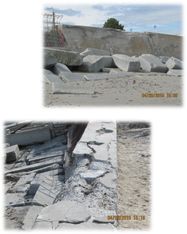

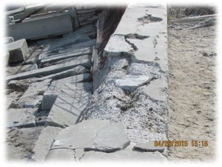

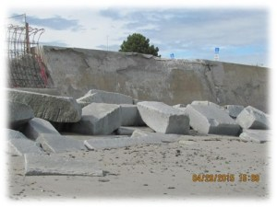

Article 22: Sidewalk Repair $45,600
Shall the Town of Hampton vote to raise and appropriate the sum of $45,650 for the maintenance, repair, re-construction and replacement of sidewalks, as needed, including $5,000 for the installation of ADA compliant ramps at crosswalks. This shall be a non-lapsing appropriation per RSA 32:7, VI and shall not lapse until this project is completed or by March 31, 2017, whichever is sooner? (Majority vote required)
What it means: The requested funding will be used to make needed sidewalk repairs.
Those in favor say: DPW will use a mix of internal resources and outside contracting to get as much done as possible while controlling costs.
Those against say: No one spoke against this Article at Deliberative Session.
Fiscal Impact: The average Hampton home valued at $329,000 would bear an increased tax cost of $5.26 if this Article passes. This is a one-time cost impact.
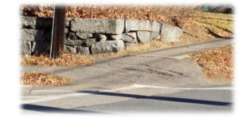

Article 23: Household Hazardous Waste Collection Day $20,000
Shall the Town of Hampton vote to raise and appropriate the sum of $20,000 to conduct a Household Hazardous Waste Collection Day du ring calendar year 2016; and to authorize the Board of Selectmen (a) to permit the Towns of Hampton Falls and New Castle to participate in said collection day at their own expense; (b) to authorize the Board of Selectmen to apply for, accept and expend for such purposes any funds from the State of New Hampshire, the Federal Government, and any private source as may become available? (Majority vote required)
What it means: The Town previously had a fund to run the Hazardous Waste Collection Day, which is now depleted. If Hampton residents wish to continue this event, it needs to be funded.
Examples of Hazardous Waste: Products such as paint thinner, spot remover, oven cleaner, furniture polish, drain opener, pool chemicals and hair spray are considered hazardous because they contain chemicals that are corrosive, explosive, reactive, flammable or toxic. As of January 1, 2008 trash disposal of products containing mercury is banned. Items included but are not limited to: thermometers, thermostats, electrical switches and relays, fluorescent light bulbs, button cell batteries.
Those in favor say: Hazardous Waste Collection Day assures that hazardous materials are not left on the street or thrown in the trash.
Those against say: No one spoke against this Article at Deliberative Session.
Fiscal Impact: The average Hampton home valued at $329,000 would bear an increased tax cost of $2.30 if this Article passes. This appropriation is for this year only.

Article 24: Revaluation of Town’s Utility Properties $225,000
Shall the Town of Hampton vote to raise and appropriate the sum of $225,000 to complete appraisals on the Town’s utility properties as part of the 2016 Town-wide revaluation of property in Hampton as required by the State Constitution and the Department of Revenue Administration under RSA 75:1, RSA 75:4 & RSA 75:8. This shall be a non-lapsing appropriation per RSA 32:7, VI and will not lapse until the Town-wide revaluation is completed or by March 31, 2017, whichever is sooner? (Majority vote required)
Note: As the Town of Hampton is required to complete appraisals on all property types as part of the 2016 revaluation this would also include all Utility properties so they, too, are appraised in accordance with their full and true market value as of April1, 2016.
The Town has now received proposals for the completion of these complex appraisal reports, the list of which includes:
- Seabrook Station Nuclear Power Plant (Hampton Assets)
- Unitil Energy Systems Inc.
- Northern Utilities Inc.
- Aquarion Water Company
- Public Service of New Hampshire
- Fairpoint Communications
- Comcast
As Hampton’s utility assets represent a substantial portion of the property tax base, it is imperative that they reflect fair and equitable assessments as of April 1, 2016.
What it means: The town-wide revaluation that was approved by voters last year does not include the properties of utilities, which are a different class of valuation (more complex).
Those in favor say: The utilities represent the highest taxpayers in town. It makes sense to have their values established in relation to each other. This will be valuable in court cases where the utilities attempt to get their property values lowered at the expense of all the other taxpayers in town. This is the most cost-effective time to do the valuations. The cost per taxpayer is reasonable in comparison to the savings that even one successful case will mean to the Town.
Those against say: There won’t be an immediate impact, so why not wait?
Fiscal Impact: The average Hampton home valued at $329,000 would bear an increased tax cost of $26.65 if this Article passes. The tax impact is for this year only.

Article 25: Social Services $174,475
Shall the Town of Hampton vote to raise and appropriate the sum of $174,475 for the cost of Hampton’s contribution to twenty (20) human service agencies in the Seacoast in the amounts corresponding to the agencies’ requests in the right hand columns as follows:
Human Service Agency | 2015 Funding | 2016 Funding Request
A Safe Place* | $5,500 | $7,500
American Red Cross | 2,000 | 2,000
Aids Response Seacoast | 2,700 | 2,700
Area Home Care & Family Services | 12,000 | 12,000
Big Brothers Big Sisters | 8,000 | 8,000
Child Advocacy Center | 1,250 | 1,250
Child and Family Services | 6,000 | 6,000
Crossroads House | 15,000 | 15,000
Families First Health & Support Center | 10,000 | 10,000
Lamprey Health Sr. Trans. Program | 4,200 | 4,200
New Generation Shelter | 2,000 | 2,000
Retired & Senior Volunteer Program | 1,800 | 1,800
Richie McFarland Children’s Center | 7,800 | 7,800
Rockingham Community Action | 25,000 | 25,000
Rockingham Meals on Wheels | 5,281 | 6,625
Seacoast Famiily Promise | 2,500 | 2,500
Seacoast Mental Health Center | 8,000 | 8,000
Seacoast Visiting Nurse | 40,000 | 40,000
Seacoast Youth Services | 2,500 | 2,500
Seacoast Assault Services * | 2,000 | 0
Transportation Assistance for Seniors (TASC) | 9,600 | 9,600
Total | $173,131 | $174,475
* Seacoast Assault Services merged with A Safe Place
These twenty human service agencies shall each be required to give a written re port at the end of the calendar year 2016 to the Board of Selectmen highlighting what the funds were used for and what impact the funds had in assisting to achieve their goals and objectives? (Majority vote required).
What it means: Each of the listed agencies will receive a donation from the town in the
Noted amount. The funds raised and donated in 2015 are also noted. The difference, where there is one, came by way of request from the agency. This is an “all or none” Warrant Article. If the Article passes, all the listed agencies receive the specified donations. If it fails, none do. Note that “A Safe Place” has merged with Seacoast Assault Services and their requested amounts have been combined.
Those in favor say: This is something we do every year. These agencies handle social issues that the town would be dealing with if the agencies were not.
Those against say: This sort of funding should be voluntary, not mandated via property taxes. A person should not be required to support all of these agencies if he or she has a philosophical disagreement with one or more on the list. No other town has mandated charitable giving.
Fiscal Impact: The average Hampton home valued at $329,000 would bear an increased tax cost of $20.73 if this Article passes. Passing the Article affects 2016 only.

Article 26: Recreation Dept Playground Equipment $115,350
Shall the Town of Hampton vote to raise and appropriate the sum of $115,350 for the purpose of purchasing the following items of equipment for the Recreation and Parks Department: 1) a one- ton dump truck for the Recreation Department to replace its current 1999 one-ton dump truck, which shall be traded in as part of the purchase if deemed to be prudent by the Recreation and Parks Department Director, Town Manager, and Board of Selectmen; 2) new playground equipment to replace obsolete playground equipment at 5 Corners Park; all as determined by the Board of Selectmen, the Town Manager and the Director of Recreation and Parks Department, and 3) to authorize the withdrawal of $115,350 from the Recreation Infrastructure Special Revenue Fund established for the purpose under Article 44 of the 2007 Annual Town Meeting? (Majority vote required.)
What it means: Every year, the needs of the Parks and Recreation Department are identified, and the voters need to approve withdrawal of the requested dollars from an established fund. That is the purpose of this Article.
Those in favor say: The 1999 dump truck is used daily 9-10 months of the year. It is corroding and has maintenance issues. The average lifespan of playground equipment is 14 years. The set at 5 corners has been in use for over 20 years. Due to the special revenue fund, there is no tax impact.
Those against say: No one spoke against this Article at Deliberative Session.
Fiscal Impact: No tax impact.

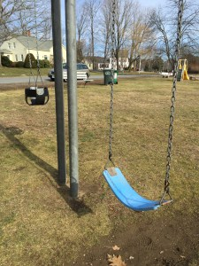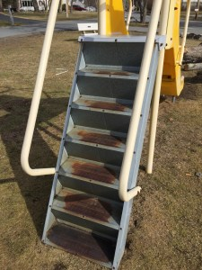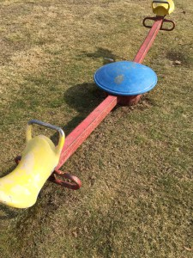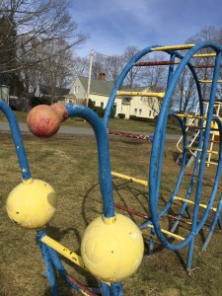

Article 27: Police Forfeiture Fund $90,000
Shall the Town of Hampton vote to raise and appropriate the sum of $90,000 to carry out all lawful functions allowed under federal, state and local criminal justice forfeiture programs and to authorize the withdrawal of that amount from the Police Forfeiture Special Revenue Fund created for that purpose under Article 55 of the 2003 Town Meeting? (Majority vote required.)
What it means: During normal police operations, items of value may be forfeited by individuals. There are expenses associated with the management of such property, including storage, auctioning, returning items where appropriate, etc. NH law permits the auctioning of this property where appropriate, and the funds so received are put into a fund. This Article seeks approval to use the funds to cover the cost of managing the forfeiture process.
Those in favor say: This is a standard, annual procedure.
Those against say: No one spoke against this Article at Deliberative Session.
Fiscal Impact: No tax impact.

Article 28: Fire Prevention Secretary – Make the Position Full-Time $45,364
Shall the Town of Hampton vote to raise and appropriate the sum of $45,364 to bring the Fire Prevention Secretary position to a 40-hour per week full-time status. This shall be a non-lapsing appropriation per RSA 32:7, VI and shall not lapse until the hiring is complete or by March 31, 2017, whichever is sooner? (Majority vote required.)
Note: Warrant article figure presented is for 39 weeks from April 1 to December 31, 2016, the amount cost thereafter is $60,486.
What it means: The Fire Prevention Secretary is responsible for working with developers and individuals who require fire permits; reviewing and registering plans; taking calls from the public; handling state and local reporting, etc. The position is currently part time, which means that the job is handled by Fire Officers when the part-timer is not on duty. As development has picked up in town, the Department is requesting that the secretarial position become full time to cover these responsibilities during the full business day.
Those in favor say: The level of activity in the Fire Prevention Office has increased with the improving economy and the increase in new building permits. Contractors need someone to go to and event planners need help understanding requirements. The amount of billing going on is unprecedented. Using Fire Officers to handle these duties when the Secretary is not on duty is not a good use of higher paid staff. There was a full time secretary at one time. It helped everyone in the community, and the operation was much smoother.
Those against say: No one spoke against this Article at Deliberative Session.
Fiscal Impact: The average Hampton home valued at $329,000 would bear an increased tax cost of $5.26 if this Article passes. This appropriation request impacts future years as well, since the increased hours are expected to continue as long as the workload persists.

Article 29: Changes to the Management Information Systems Capital Reserve Fund
Shall the Town of Hampton vote to raise and appropriate the sum of $0 for the replacing, upgrading and modifying of the existing computer system operated by the IT division under the Finance Department and authorize the withdrawal of $0 from the Management Information Systems Capital Reserve Fund created for that purpose by Article 27 of the 1997 Town Meeting; And To vote, after the foregoing withdrawal of the sum of $0 is made, to maintain the said Management Information Systems Capital Reserve Fund? (Majority vote required.)
What it means: This Article was nullified at Deliberative Session. Those in attendance decided they did not like the Article. By changing the dollar amount to $0 and changing it to “maintain” the account (as opposed to the original wording to “discontinue” the account) they essentially took it off the docket for voters to approve or disapprove. It won’t matter if the Article passes or fails, the status quo will remain in place.
Fiscal Impact: No tax impact.

Article 30: Hampton Conservation Fund $20,000
Shall the Town of Hampton vote to raise and appropriate the sum of $20,000 to be placed in the Hampton Conservation Fund; this fund is used to “acquire, maintain, improve, protect or limit the future use of, or otherwise conserve and properly utilize,” open spaces and conservation easements in Hampton in accordance with RSA 36-A: Sections 1 through 4, inclusive. Recent acquisitions such as the Batchelder Farm Conservation Easement have significantly reduced the size of the Fund. The goal is to return the Fund to adequate levels to enable the Commission to conserve additional lands on behalf of the Town of Hampton. The Conservation Fund contains previously approved appropriations or gifts, for the same or similar purposes that have been made to the “Conservation Commission Accumulation Fund,” the “Conservation Land Fund,” and the “Conservation Land Acquisition Fund”? (Majority vote required.)
What it means: This fund is a way of saving for opportunities, similar to the Capital Reserve Fund. Voter approval of this Article each year is primarily how the Conservation Commission replenishes the fund it uses to preserve and maintain open spaces.
Those in favor say: The Town needs to support conservation land for the recreational value as well as to help with excess storm water.
Those against say: No one spoke against this Article at Deliberative Session.
Fiscal Impact: The average Hampton home valued at $329,000 would bear an increased tax cost of $2.30 if this Article passes.

Article 31: Town War Memorial $5,000
Shall the Town of Hampton vote to raise and appropriate the sum of $5,000, said sum of $5,000 to come from the Unassigned Fund Balance, a fund containing unexpended appropriations from prior years, as of December 31, 2015, and with no amount to be raised from taxation, to provide partial funding for the planning of a Town War Memorial dedicated to the Town’s sons and daughters who have served in the Militia for the protection of the community in Colonial Wars from 1638 to 1774, and who have fought in wars for our Nation from 1775 to date, and to provide appropriate space on such memorial for those who shall serve in future wars. The Board of Selectmen to work with the Hampton Post 35 of the American Legion and such individuals as the Board of Selectmen shall appoint to plan the memorial, and its place of erection on a parcel of Town owned land, and to authorize the Board of Selectmen to apply for, accept, and expend for such purpose any funds from the State of New Hampshire, the Federal Government, or any private source, as may become available, to add to the sum. This shall be a non-lapsing appropriation per RSA 32:7, VI and will not lapse until the project is completed or by March 31, 2019, whichever is sooner? (Majority vote required.)
What it means: This Article would support the withdrawal from surplus funds in the amount of $5,000 to create a memorial to those from Hampton who have served in various conflicts on behalf of their country. The memorial would list the more than 2,000 people who served from 1638 – 1774, and from 1775 – present.
Those in favor say: Several speakers, including a representative from the American Legion Post, expressed support for this Article.
Those against say: No one spoke against this Article at Deliberative Session.
Fiscal Impact: There is no direct tax impact, however the $5000 would not go into the General Fund to help offset taxes. This is expected to be a one-time expenditure.

Article 32: Transfer Heritage Funds to the General Fund
Shall the Town of Hampton vote to distribute to the general fund all funds that were left in the Heritage Fund, currently amounting to approximately $5,329.58 plus any additional interest earned thereon, from past monies appropriated and gifts of money, which are no longer needed due to the abolition of the Heritage Commission as a result of the passage of Article 35 at the 2015 Annual Town Meeting? (Majority vote required)
What it means: Last year, voters approved the dissolution of the Heritage Committee. That group had a fund with a balance of $5329.58. This Article seeks to close that account, and transfer the balance into the general fund, thus reducing the amount needed to be raised by taxes for all other purposes approved via this Warrant.
Those in favor say: This is a common sense thing to do since the committee no longer exists. Where needed, DPW can continue to maintain the historical buildings.
Those against say: No one spoke against this Article at Deliberative Session.
Fiscal Impact: No tax impact.

Article 33: Change the Name of the Cemetery Burial Trust Fund
Shall the Town of Hampton vote to change the title of the “Cemetery Burial Trust Fund” that was first created by Article 26 at the 1986 Town Meeting for the maintenance of Town owned cemeteries, to the “Cemetery Maintenance Trust Fund,” and to confirm that currently, each Town Meeting has the authority to make expenditures from both the principal and the interest in said Fund (the interest from which is otherwise to be withdrawn annually and used for the maintenance of cemeteries) and to make changes in the terms of said Fund as needed? (2/3 vote required.)
What it means: This fund was established in 1986 with $18,000. The fund’s current balance is over $500,000. The combination of deposits to the fund for burials, interest earned and capital appreciation is greater than the voter-approved withdrawals from the fund over the past 30 years. This Article seeks to confirm the ability of the voters at future Town Meetings to approve or disapprove specific proposals to withdraw from both principal and interest. The Article would also change the name of the fund to be more in keeping with its larger purpose (“maintenance” to encompass upkeep as well as burials). The required voting outcome was increased to a 2/3^{rds} majority at Deliberative Session because the Department of Revenue Administration thought it could be interpreted as a change of purpose.
Those in favor say: As long as the Town meets the maintenance & upkeep needs of the cemeteries, the voters should have the ability to approve withdrawals from the fund for specific purposes. Otherwise, the fund will continue to grow, while we accumulate bond debt for other projects.
Those against say: No one spoke against this Article at Deliberative Session.
Fiscal Impact: No tax impact.

Article 34: 100% of Cable Franchise Fees to Channel 22
Shall the Town of Hampton vote to change the percentage distribution of Franchise Fees received from the Cable TV provider as voted under Article 16 of the 2013 Annual Town Meeting so that 100% (instead of 25%) of the funds received from the Franchise Fees are placed in the Hampton Cable TV Local Revolving Fund and are allowed to accumulate from year to year, and shall not be considered to be part of the Town’s unassigned fund balance in accordance with the provisions of RSA 31:95-h as previously voted? (Majority vote required)
What it means: Since around the year 2000, there is a Cable Franchise Fee added to each cable customer’s bill to the tune of around 2.6%. This money is turned over to the Town. Around 25% of this money has historically been used to fund Channel 22 and the balance went to the General Fund to offset taxes. With the recent creation of Chanel 13 to support SAU 90, the Board of Selectmen felt that the percentage should be increased to around 40% to support technology acquisition and upkeep for both Channel 22 and Channel 13. At Deliberative Session, this percentage was changed from 40% to 100%.
Those in favor say: The rationale by those who changed the percentage was that the amount of the fee that was not dedicated to a specific purpose (historically the 75% that went to the General Fund) could be considered a tax, not something New Hampshire residents want to see. Those seeking to amend the Article from 40% to 100% felt that all of the money should be for a specific purpose, or else should not be collected at all.
Those against say: The franchise fee is equal to about $328,000 per year which is much more than needed to acquire and maintain technology for the two stations. Once that money is allocated to the Cable Fund, it cannot be touched for any other reason. If we want to reduce the amount of money collected via the Cable Franchise Fee (to avoid the “tax” issue), we need to wait for the current contract between Comcast and the Town of Hampton to expire, and negotiate different terms going forward. No one can change the fee prior to the contract expiration. In the meantime, to put that much money into the Cable Fund when it is not needed there does not make much sense.
Fiscal Impact: No tax impact.

Article 35: Disposal of Surplus Town Equipment and Materials
Shall the Town of Hampton vote to a mend Article II, Section 1 of Chapter 469 of the Hampton Code (the Disposal of Surplus Town Equipment and Materials Ordinance adopted under Article30 of the 2012 Annual Town Meeting) as follows:
Amend Chapter 469, Article II, Section 1. Exclusions, by adding the following language at the end of the list of Exclusions in this Section between the word “herein” and the period.
Surplus and no longer usable equipment or equipment containing scrap metals that can be sold to a metals or junk dealer by the Town for sums in excess of its auctionable value as determined by the Town Manager or his designee and approved by the Board of Selectmen? (Majority vote required)
What it means: This allows the Selectmen to dispose of obsolete equipment as scrap, if that is more economical than auctioning the equipment.
Those in favor say: This provides another avenue to dispose of old equipment and is a sensible way to do it.
Those against say: No one spoke against this Article at Deliberative Session.
Fiscal Impact: No tax impact.

Article 36: Arnold and Martel Properties Conveyed to SAU 90
Shall the Town of Hampton vote to authorize the Board of Selectmen to convey to the Hampton School District, upon such terms and conditions as the Selectmen may determine are appropriate and in the best interests of the Town, all of the Town’s right, title and interest in two separate vacant parcels of land, the first commonly known as the Arnold property (Tax Map 161-51), which has been under lease to the Hampton School District for the purpose of an off street bus loading/unloading area in accordance with Article 43 of the 1988 Annual Town Meeting, and the second commonly known as the Martel property, (a part of Tax Map 176 Lot 14, (subdivision may be required)), over which the Hampton School District has an easement for a travel lane also in accordance with said Article 43 from the 1988 Annual Town Meeting, both located on Academy Avenue; these conveyances are contingent upon the successful passage of the currently proposed bond issue for renovations to the Hampton Academy and the carrying out of that project, and are further to be made subject to a reverter of title to the Town of Hampton of said parcels should they no longer be needed by the Hampton School District for school purposes? (Majority vote required)
What it means: There are two small parcels of land which are owned by the Town and which have been used by Hampton Academy since 1988 to provide a space for off-street bus loading and unloading. This Article authorizes the Board of Selectmen to deed the two parcels to the school. There is another Article on the SAU 90 ballot that authorizes SAU 90 to accept the transfer. If the voters approve this transaction, it would be contingent upon the Hampton Academy renovations being approved, and contingent upon the property being needed by the school going forward. If the school does not need it for school purposes in the future, the small parcels of land would revert to the town.
Those in favor say: The only speaker at Deliberative Session reinforced the fact that the SAU 90 bond request (on the school ballot) must pass in order for this Article to be acted upon.
Those against say: No one spoke against the concept at Deliberative Session.
Fiscal Impact: No tax impact.

Article 37: Acceptance of Streets at No Cost
Shall the Town of Hampton vote to accept “as is” the lettered streets A through Q and the streets in White’s Island, so-called, known as Atlantic Avenue, Bradford Avenue, Concord Avenue, Dover Avenue, Epping Avenue, Haverhill Avenue and River Avenue, as Class V Town Highways, said highways having been surveyed by Parker Survey Assoc. Inc., and filed in the Rockingham County Registry of Deed as Plan D-12567 (Sheets 1-5) and as Plan D-12566 (Sheets 1-2) respectfully, and constructed by the Hampton Beach Improvement Company on Town property under a lease approved by Town Meeting, said lease dated and signed on April 24, 1897, acceptance action having not been taken by a prior Town Meeting. These acceptances shall be at no cost to the Town? (Majority vote required)
What it means: This is a housekeeping matter to correct an oversight that has persisted since 1897.
No one spoke for or against this Article at Deliberative Session.
Fiscal Impact: No tax impact.
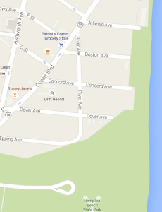

Article 38: Discontinue E Street as a Public Way
Shall the Town of Hampton vote to discontinue E Street as a Public Way in accordance with the provisions of RSA 231:43, provided that the discontinuance shall be of no force and effect until every property owner abutting E Street signs a waiver, to be prepared by the Town Attorney, of any appeal under RSA 231:48 from such discontinuance and of all damages that could be sought under RSA 231:48 as a result of such discontinuance, or until six months has elapsed after the vote to discontinue without any such appeal having been made, whichever comes first? (Majority vote required).
What it means: “E” Street is a town-owned street that primarily exists on paper, and the Town would be surrendering title to “E” Street to the owners of the Hampton Casino. As background, this section of Hampton Beach is laid out and organized according to the letters of the alphabet “A” Street, “B” Street, etc. In the late 1890’s, the Hampton Beach Casino was constructed in an area that fell between “D” Street and “F” Street. Thus, “E” Street never actually existed as a street but has been maintained as a theoretical street on the books. This Article seeks to discontinue it.
Those in favor say: “E” Street never really existed as an actual street, and we should eliminate it.
Those against say: There is no assurance that the Casino will always be there to bridge the two streets, or even that the two sides of the Casino will always be owned by the same party. Those who spoke against it wondered what benefit derives from the discontinuance, since there might be future need for the differentiation of the individual street names.
One commenter said he wanted the Town to obtain in writing assurances from the Casino owner that the “E Street” entrance to the property will be available for traffic improvements in perpetuity. One more year won’t change a thing after 118 years, and Hampton is not likely to cut a hole in the middle of the Casino if this is not passed this year.
Fiscal Impact: No tax impact.
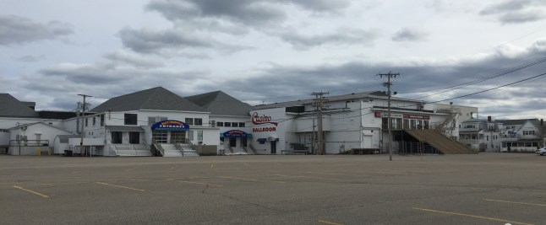
Article 39: Discontinue a portion of Old Park Avenue
Shall the Town of Hampton vote to discontinue a portion of Old Park Avenue remaining after its reconstruction, caused by the relocation of Route 1 in 1960, in accordance with the provisions of RSA 231:43, provided that the discontinuance shall be of no force and effect until every property owner abutting the area of discontinuance signs a waiver, to be prepared by the Town Attorney, of any appeal under RSA 231:48 from such discontinuance and of all damages that could be sought under RSA 231:48 as a result of such discontinuance, or until six months has elapsed after the vote to discontinue without any such appeal having been made, whichever comes first?
What it means: Prior to the re-routing of Route 1 in 1960, Park Avenue was situated between the two houses numbered 19 and 25. With the extension and reshaping of Park Avenue, the small section of the road that once was between the two houses was returned to grass, but is still on the books as a road. This article seeks to officially discontinue the road.
Those in favor say: By discontinuing the road, the small strip of land will allow one homeowner to have the legally required frontage, and the other to be able to build a garage. The town benefits because the land will become part of the tax base.
Those against say: No one spoke against the concept at Deliberative Session.
Fiscal Impact: No tax impact.
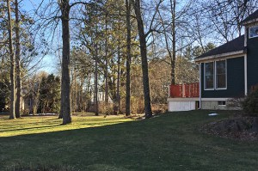

Petitioned Articles

Article 40: Removal of Deed Restriction on 3 Toppan St – 2 Dwellings on One Lot
On the petition of John and Judith Doherty, and at least 25 Hampton registered voters, shall the Town of Hampton vote to re move the first sentence of deed restriction number 4, relating to allowing only one single-family dwelling to be placed on the lot. This request is for the limited purpose of allowing these owners of two seasonal dwellings at 3 Toppan Street (Hampton tax map number 134, lot number 86) to replace one existing and failing seasonal dwelling with a properly built year-round dwelling, such that the owners can then relocate and retire to the Town of Hampton. The new dwelling will meet all local building and zoning codes. There are currently two dwellings on said lot. Further to authorize and direct the Selectmen to execute, deliver and record notice of this vote at the Rockingham County Registry of Deeds at no extra cost to the Town? (Majority vote required).
What it means: This is one of the parcels of land that the town leased to Hampton residents in the 80’s, all of which had certain restrictions associated with them. However, even at the time of the leased land sale, not all of the restrictions had been evenly enforced. The owners of the referenced property have had 2 seasonal structures on one small lot (.13 acre lot). This Article seeks to relax the deed restriction that disallows more than one dwelling on a lot so the owners can renovate one of the structures for year-round living.
Those in favor say: A neighbor said this is a nice family that would be welcomed year-round. There are currently 2 dwellings on the property and have been for some time.
Those against say: People who are opposed to this idea say that the lot is too small for 2 dwelling units if one of them is to be year-round. Lot sizes in town take into consideration issues such as snow storage, runoff, drainage, etc.
Fiscal Impact: No tax impact.
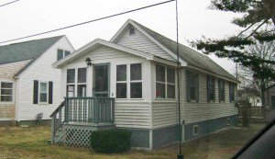
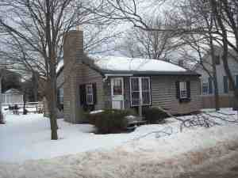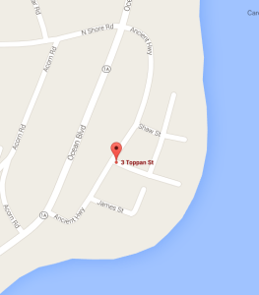

Article 41: Removal of Deed Restriction – 30 Dover Ave – Expand Existing Dwelling on Current Foundation
On Petition of Daniel Considine and twenty-five (25) or more registered voters, shall the Town of Hampton vote:
To remove and release a portion of deed restriction #4, first appearing in the deed from the Town of Hampton to Cora M. Carbonneau dated September 17, 1984 and recorded in the Rockingham County Registry of Deeds at Book 2512, Page 458, as to the premises located at #30 Dover Avenue (Tax Map 296, Lot 161-0 and owned by Daniel Considine, Kelly Considine, Daniel Considine, Jr. and Ayla R. Considine, in order to allow for the expansion of the existing dwelling, on its existing foundation The portion of the deed restriction #4 to be removed reads as follows: “The Grantee will not directly build upon the premises within seven (7) feet of any boundary line.”; and further, to authorize and direct the Town Clerk to execute and deliver t o the owners of said lot for recording, a notice of this Vote at the Rockingham County Registry of Deeds, at no cost to the Town? (MAJORITY VOTE REQUIRED.)
What it means: This is one of the parcels of land that the town leased to Hampton residents in the 80’s, all of which had certain restrictions associated with them. One of the restrictions was that the owners would not build within 7 feet of the boundary line, which is what the owners wish to have removed. If approved, this Article will amend the deed restriction only. Any other permitting requirements or variance requests would still need to be addressed via the appropriate Boards in Town.
No one spoke in favor or against this Article at Deliberative Session.
Fiscal Impact: No tax impact.
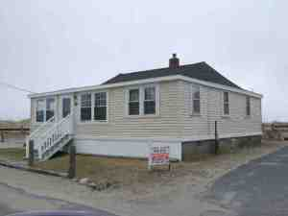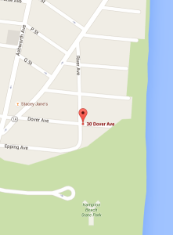

Article 42: Prohibit Road Closures Relating to Special Events, with Exceptions.
On Petition of Stephen Joyce and at least 25 registered voters, we direct the Board of Selectmen to not approve any special event requests that result in the closure of any road in the Town of Hampton. The only allowed exceptions are the Annual Seafood Festival, Neighborhood Block Parties and Parades? (Majority vote required)
What it means: The petitioners are asking the Town to not approve any events (exceptions as stated) that would close the roads in such a way as to hinder resident comings and goings during the event. It was noted at Deliberative Session that this might not be a legally enforceable Article, because the opening and closing of roads in some cases may be subject to other regulations and jurisdictions.
Those in favor say: Those who spoke at Deliberative Session expressed frustration at not being able to come and go as they wished for many hours at a time. For example, at one annual road race, Ocean Boulevard from the Beach District to High Street is closed from 8:30 – 11:00 AM. Others report not being able to get home from morning activities because all the roads surrounding their homes were blocked. Proponents encourage approving this Article if for no other reason than to send a message to the Board of Selectmen that the people in Town are very frustrated with the local closures, especially those that benefit a for-profit organization with very little upside to Hampton taxpayers.
Those against say: Aside from the legality question of the potential ordinance, opponents say the events support local businesses, and provide a venue for various athletic and other activities for the residents of Hampton as well as the many visitors. They referred to the road closures as a minor and temporary inconvenience and thought it was worth it for the benefits provided.
Fiscal Impact: No tax impact.

Article 43: Christmas Parade $3,000
On the petition of John Nyhan and at least 25 Hampton registered voters, shall the Town of Hampton raise and appropriate $3,000 to pay to Experience Hampton Inc, the organizer of the 2010 to 2015 Hampton Christmas Parades, to help defray the expenses of the 2016 Christmas Parade and related activities? (Majority vote required)
What it means: This is an annual donation to Experience Hampton to help fund the Christmas parade in town
Those in favor say: The parade takes place early in December, and tries to involve many groups within town, including businesses, schools and local officials. The total cost of the parade is $15,000 of which the taxpayers are being asked to absorb a small fraction.
Those against say: No one spoke against this Article at Deliberative Session.
Fiscal Impact: The average Hampton home valued at $329,000 would bear an increased tax cost of $.35 if this Article passes.

Article 44: Final Repairs to Town Clock $35,000
On the Petition of Amy Hansen and at least twenty-five other registered voters of the Town of Hampton, shall the Town of Hampton raise and appropriate the amount of $35,000 to help defray the cost of carrying out repairs and maintenance to the Town Clock. Such funds raised by this article to be used a long with privately raised funds that are currently in the Town’s possession to complete the work of constructing a tower to house the clock and for the clock’s repair and installation in that structure. This shall be a non-lapsing account per 32:7, VI and will not lapse until the earlier of: i) all funds raised by this Article being expended for the construction, repair or maintenance of the tower and clock, or ii) December 31, 2021? (Majority vote required)
What it means: This clock was given as a gift to the town in 1897, and was a part of Hampton’s town center for many years. It came crashing down during a fire decades ago. It was rescued by Hampton residents, only to be relegated to the basement of Town Hall for a number of years. At some point, a concerned group of citizens got access to the clock and have been working to restore it. The plan is to mount it on a to-be-erected, separately funded tower on the green in front of Centre School.
Those in favor say: The clock is part of our heritage and should be salvaged. Individual residents have cared enough about this to dedicate many hours to restoring it and raising money for it, but now need the help of other Hampton homeowners. Last year’s unsuccessful request for $75,000 has now been reduced to $35,000 as more funds have been raised privately. The clock belongs to the Town of Hampton and the town should participate financially in the restoration.
Those against say: Some people think the funds needed should be raised by private efforts and donations. Another wondered about the noise of the bell.
Fiscal Impact: The average Hampton home valued at $329,000 would bear an increased tax cost of $4.28 if this Article passes.
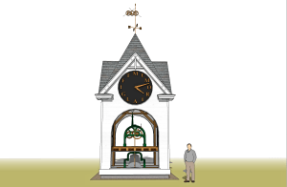

Article 45: Remove Deed Restriction – 10 Ancient Highway – Reconstruct Front of Building within 7 ft of Boundary Line
On petition of 25 legal voters of the Town of Hampton:
To release and remove a portion of deed restriction #4 (BK2509 P1919) as to the oceanfront side only of the premises at #10 Ancient Highway (Tax Map 134, Lot # 105) owned by Peter and Rita Cary, in order to allow reconstruction of the existing non-conforming oceanfront side of the dwelling, as part of the substantial renovation of the dwelling. The portion of the deed restriction #4 to be removed as to the oceanfront side of the dwelling only reads as follows: “The Grantee will not erect any buildings upon the premises within seven (7) feet of any boundary line. The Hampton Zoning Board has approved variances for the other requested work on the property. Further to authorize and direct the Town Clerk to execute and deliver to the lot owners for recording a notice of this vote at the Rockingham County Registry of Deeds, at no cost to the Town? (Majority vote required)
What it means: Like Articles 40 and 41, this is one of the parcels of land that the town leased to Hampton residents in the 80’s, all of which had certain restrictions associated with them. One of the restrictions was that the owners would not build within 7 feet of the boundary line, a restriction that the owners wish to have removed. If approved, this Article will amend the deed restriction only. Any other permitting requirements or variance requests would still need to be addressed via the appropriate Boards in Town.
No one spoke in favor or against this Article at Deliberative Session.
Fiscal Impact: No tax impact.
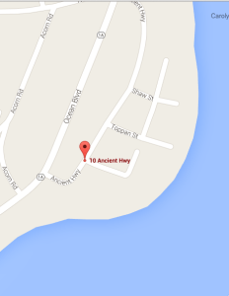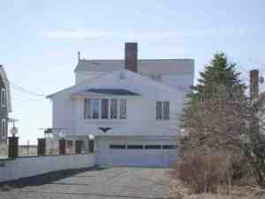

Article 46: Reduce Percentage of Budget Dedicated to Debt Service
By petition of Kerstin Wilcox and at least 25 registered voters, shall the Town of Hampton seek to gradually reduce the amount of the budget dedicated to debt service from the current 12% to a maximum of 6%, which is the average percentage of debt service for all New Hampshire towns? Methods of bringing the debt down might include the use of capital improvement funds to save for projects requiring bonds, thus avoiding or reducing interest debt, or timing projects such that implementation coincides with the expiration of previous debt. This advisory article does not speak to any specific project, but rather addresses the desire of taxpayers to control the overall percentage of the budget dedicated to paying down bond debt? (Majority vote required)
What it means: This advisory Article seeks to bring awareness to the fact that Hampton currently dedicates 12 cents of every tax dollar collected to debt requirements, twice the level of the average New Hampshire town. Approval of this Article would send a message encouraging the timing of projects and/or capital reserve funds to reduce or avoid bond debt in the future.
Those in favor say: This is a good thing to be aware of, and a sensible approach.
Those against say: No one spoke against this Article at Deliberative Session.
Fiscal Impact: No tax impact.

Article 47: Town Boards to Provide Details and 4-Days Notice for Public Meetings
By petition of Steven Jusseaume and at least 25 registered voters, shall the Town of Hampton, in the interest of making the best use of Town employees’ and volunteers’ time, require that detailed agendas for all public meetings be posted at least four days prior to the date of the meeting? The agendas should include a list of the Town Departments, Boards and Commissions that are being asked to participate in the meeting, with a brief statement of the topic(s) to be discussed. The items on each agenda should be listed in the order in which they will be discussed, with the understanding that occasional and unavoidable last-minute changes may need to be made. Each agenda shall be posted at Town Hall, at the Lane Memorial Library, and on the appropriate page on the Hampton Town website? (Majority vote required)
What it means: Although most boards abide by this courtesy, according to the petitioners it is not always the case. If a Board holding a public meeting does not issue a detailed, timely agenda, members of the public cannot properly decide whether or not they wish to attend the meeting. Further, when the presence of Town employees or volunteers is required but those people are not notified until the last minute, it creates issues with scheduling other Town business. This Article aims to remedy that situation.
Those in favor say: It makes sense to require this, and since most Boards do this anyway, it is not seen as a hardship. The Article recognizes there may be unavoidable exceptions to the rule.
Those against say: No one spoke against this Article at Deliberative Session.
Fiscal Impact: No tax impact.

Article 48: Reduce the size of the Budget Committee

On petition of Nathan Page and (25) twenty five or more registered voters of Hampton, shall the Town of Hampton reduce the number of at-large members serving on the Hampton Municipal Budget committee to 6 (not including representatives from other Boards) as provided under RSA 32:15-IV? This change will take place via attrition as terms expire beginning in 2016, until the number of at-large members of the Committee reaches 6. Subsequently, annual elections will be held to maintain the membership of the Municipal Budget Committee at 6 at-large members.]
What it means: The Hampton Municipal Budget Committee currently consists of 12 at-large members, and 3 representatives from other boards for a total of 15. This Article seeks to reduce the size of the committee to 6 at-large members, plus the 3 from other boards for a total of 9. The reduction in the size of the committee would be accomplished via attrition: Starting in 2016, as existing terms expire, no new candidates would be sought, until the number of filled seats falls below 6. At that point, candidates would be sought to maintain the size of the board at 9 members (6 at-large and 3 appointed from other Boards as they are now.)
Those in favor say: The sheer size of the Budget Committee makes it unwieldy. It takes more time to get things done both for the Budget Committee itself and for the Department Heads who must present their budgets and rationales. No other board in town has as many members as the Budget Committee does. The NH statutes allow for Budget Committee members ranging from 3 – 12 at-large members.
Those against say: Those who were against the Article were concerned not so much about reducing the size of the Committee, which was generally thought to be a good idea, but about losing experienced members and not being able to choose who would stay on the board in the short term.
Fiscal Impact: No tax impact.

Article 49: Modify Deed: Fence Restriction
Upon petition of at least twenty-five (25) legal voters of the Town of Hampton, New Hampshire, to see if the Town will vote to modify restriction #3 in those deeds recorded at Book 2579, Page 2377, Book 2591, Page1378, Book 4721, Page 2612 and Book 4721, Page 2616 to permit fencing no higher than six (6) feet on that property located at 14, 16-20, 22 and 26 N Street shown as Lots 114, 115, 116 and 117 on Tax Map 293.
What it means: “N” street is in a part of town that is heavily congested in the summer. There are area deed restrictions that disallow a fence from being higher than 3 feet. This means that the residents are not able to distance themselves from the noise and lights from the heavy Hampton Beach traffic each summer. A developer is doing some work on lots in this area, and wishes to provide higher fences for the privacy of the residents.
Those in favor say: A speaker stated that he supports this Article and had suggested that the developer submit an Article to remove that particular deed restriction from all the lots in the area, but the developer only asks the voters to consider lifting the deed restriction for a specific group of lots.
Those against say: No one spoke against this Article at Deliberative Session.
Fiscal Impact: No tax impact.

SAU 90 Articles

SAU 90 Article 1: Hampton Academy Renovation
Shall the Hampton School District vote to raise and appropriate the sum of $24,945,000 for reconstructing and equipping the Hampton Academy middle school; and authorize the issuance of not more than $24,945,000 of bonds or notes in accordance with the provisions of the Municipal Finance Act (RSA Chapter 33); and authorize the School Board to issue and negotiate such bonds or notes and to determine the rate of interest thereon; and further to raise and appropriate the additional sum of $460,550 for the payment of the first year’s interest on the bonds or notes authorized by this article, and authorize the School Board to apply for, accept and expend any grants for this purpose and take any other action necessary to carry out this vote? The School Board and the Budget Committee recommend this appropriation. (Three-fifths vote required.)
What it means: What is being proposed is a comprehensive renovation of Hampton Academy for a total cost of $24,945,000. The project would address infrastructure needs such as new roofs, windows and air quality issues; space to accommodate current technology and learning methods and would also incorporate a Community Room. The cost would be financed through bond debt.
Those in favor say: Information has been put forward by SAU 90, and is the basis for this section. A link to the Hampton Academy Renovation Project page can be found at the bottom of this section.
Images of the school and the need can be seen by clicking here:
Hampton Academy
Following are some of the highlights of the project as found in the SAU 90 materials:
- The building was originally built in 1939, with additions in 1961 and 1974.
- The building houses Grades 6-8.
- The project will add 51,000 square feet and will renovate 63,300 square feet.
- Specifics of the project, which will respect the character of the site:
- Re-design to better protect flow of students and visitors for safety reasons
- New roofs, windows, and technology infrastructure
- Improved parking with safer traffic flow
- Upgraded mechanical, electrical, air quality, data and building safety systems
- Community auditorium with fixed seating for 550
- Community Room and public meeting space with video recording for Channel 13
- Why now? The needs of Hampton Academy have been researched for years and there is a carefully vetted design for the work. Program and safety concerns continue to change with the changing society. The building and the additions are old, and many expensive infrastructure repairs will need to be undertaken with or without the re-design. Retiring bond payments can help fund this project, and interest rates are not likely to get lower than they are now.
- If the project is NOT undertaken as currently proposed, the Town will still need to address major infrastructure issues including: roof replacement, electrical upgrades, fire suppression, air quality, a complete restroom renovation, and ADA code compliance. Putting the project off is likely to incur rising construction costs and rising bond rates, making future repairs more expensive for taxpayers.
- The dollars requested are stated as being the “Guaranteed Maximum Price.”
Those against say: Those who have expressed issues with the proposal focus on:
- The overall cost of the project and the impact on the tax bill
- Other Town needs such as water drainage issues that will also need to be addressed
- The scope of the renovation and whether there might be a less expensive option
Fiscal Impact: The average Hampton home valued at $329,000 would bear an increased tax cost of $55.93 in 2016 if this Article passes. There will be future year impacts as well, with the 2017 cost estimated at $106.26 for the average-valued home.
http://www.sau90.org/node/hampton-academy-building-project
HA Project

SAU 90 Article 2 – Operating Budget $20,184,320
Shall the School District raise and appropriate as an operating budget, not including appropriations by special warrant articles and other appropriations voted separately, the amounts set forth on the budget posted with the warrant, or as amended by vote of the first session, for the purposes set forth therein, totaling $20,184,320? Should this article be defeated, the default budget shall be $20,256,680, which is the same as last year, with certain adjustments required by previous action of the District or by law; or the governing body may hold one special meeting, in accordance with RSA 40:13, X and XVI, to take up the issue of a revised operating budget only. (Majority vote required.)
Note: Warrant Article #2 (operating budget) does not include appropriations in any other warrant articles.
What it means: The proposed Operating Budget for Hampton School District is $72,360 less than the Default Budget. The Default Budget is defined as the prior year’s budget increased by contractual obligations, debt service and any Warrant Articles passed by the voters. Approval of the Article will result in the lower budget.
Those in favor say: The Operating Budget is less than the Default Budget, so it makes sense to vote for that.
Those against say: No one spoke against this Article at public hearings.
Fiscal Impact: The average Hampton home valued at $329,000 would bear a decreased tax cost of $8.79 if this Article passes.

Article 3: SAU 90 – Collective Bargaining Agreement – Seacoast Education Association
To see if the School District will vote to approve the cost items included in the collective bargaining agreement reached between the Hampton School Board and the Seacoast Education Association covering the four year period from July 1, 2016 to June 30, 2020 which calls for the following increases in salaries and benefits at the current staffing levels:
Year | Estimated Increase
2016-17 | $239,020
2017-18 | $254,533
2018-19 | $252,502
2019-20 | $250,748
and further raise and appropriate the sum of $239,020 for the 2016-17 fiscal year, such sum representing the additional costs attributable to the increase in salaries and benefits required by the new agreement over those that would be paid at current staffing levels in accordance with the most recent collective bargaining agreement. (Majority vote required.)
What it means: School officials have negotiated with the Seacoast Education Association, representing about 120 teachers. The amounts noted represent less than 1% increases, plus additional “step” increases. The voters must now approve the increase.
Those in favor say: These negotiations, similar to other collective bargaining agreements in town, are a compromise between “give backs” related to health insurance, and the need to maintain competitive salaries for teachers in Marston School, Centre School and Hampton Academy.
Those against say: No one spoke against this Article at public hearings.
Fiscal Impact: The average Hampton home valued at $329,000 would bear an increased tax cost of $28.29 in 2016 if this Article passes. Subsequent years included in the contract would increase the average homeowners taxes by about $30.00 per year.

Article 4: SAU 90 Marston and Centre School Repairs – $300,000
To see if the School District will vote to raise and appropriate the sum of $300,000 to continue long term maintenance, repair and modernization work to include technical and/or engineering services at Hampton’s Marston and Centre school buildings and grounds? This article is a continuation of an annual program planned to keep the buildings updated and in good condition, thereby protecting the taxpayer’s investment. Projects planned for 2016-17 are listed below. This will be a non-lapsing appropriation per RSA 32:7 VI and will not lapse until these projects are completed or June 30, 2018, whichever is earlier. (Majority vote required.)
Marston School
Replace roof over original building and 1975 addition (phased) $215,000
Implement security improvements (phased) 25,000
$240,000
Centre School
Replace original classroom sinks and counter tops (phased) $ 20,000
ADA improvements (district-wide) 5,000
Replace hallway entrance doors to Gymnasium 5,000
Roof repairs (ongoing) 5,000
Implement security improvements (phased 25,000
$ 60,000

What it means: The Article is self-explanatory – the funds are sought to keep the two schools in good condition.
Those in favor say: This is a routine request to maintain the buildings in good order.
Those against say: No one spoke against this Article at public hearings.
Fiscal Impact: The average Hampton home valued at $329,000 would bear an increased tax cost of $35.50 in 2016 if this Article passes. Approval of this Article affects 2016 only.

Article 5: SAU 90 Conveyance of two parcels for the Hampton Academy renovation
Shall the School District vote to authorize the School Board to accept conveyance of two parcels of property from the Town of Hampton on such terms and conditions as the School Board determine are appropriate, the first commonly known as the Arnold property, and the second being known as the Martel property? Both parcels abut the property of the School District on Academy Avenue and have been leased to and used by the Hampton School District for many years for school bus loading and unloading and staff parking. (Majority vote required).
What it means: This is the corollary of Article 36 on the main ballot. The voters must approve both sides of the conveyance – the Town to deed the properties to SAU 90, and for SAU 90 to accept the conveyance. This would only be effective if SAU 90 Article 1 is approved by the voters.
What people are saying: There have been many comments with regard to the Hampton Academy renovation (covered under Article 1), but we are not aware of any discussions specifically related to the conveyance of these parcels.
Fiscal Impact: No tax impact.

Article 6: SAU 90 Sacred Heart School Child Benefit Services – $45,600
To see if the School District will vote to raise and appropriate funds in the amount of $45,600 to provide child benefit services, in accordance with RSA 189:49, for students who are residents of the Hampton School District and attend Sacred Heart School located in Hampton, New Hampshire. BY PETITION. (Majority vote required).
What it means: Sacred Heart School is a private school in town. 48 Hampton residents attend Sacred Heart as opposed to attending the Hampton public schools. This Article asks for an offset for child benefit services in lieu of the taxpayers paying for the students to attend public school.
Those in favor say: These students would otherwise be attending the public schools at an Average cost per student of $15,212. The Article asks for $950 per student. These funds help to cover a nurse, educational technology, supplies and textbooks. Funds are not used for any religious purposes.
Those against say: One speaker had an issue with supporting a religious organization, even if the funds were not specifically used for religious purposes.
Fiscal Impact: The average Hampton home valued at $329,000 would bear an increased tax cost of $5.40 in 2016 if this Article passes. Approval of this Article affects 2016 only.
SAU 21 Articles

SAU 21 Article 1: Cooperative School District Budget – $23,810,213
Shall the School District raise and appropriate as on operating budget, not including appropriations by special warrant articles and other appropriations voted separately, the amounts set forth on the budget posted with the warrant ora s amended by vote of the first session, for the purposes set forth therein, totaling $23,810,213? Should this article be defeated, the default budget shall be $23,552,045, which is the same as last year, with certain adjustments required by previous action of the School District or by law; or the governing body may hold one special meeting, in accordance with RSA 40:13, X and XV!, to take up the issue of a revised operating budget only. (Majority vote required.)
Note: Warrant Article #1 (operating budget) does not include appropriations in any other warrant articles.
What it means: The proposed Operating Budget is $258,168 or 1% more than the Default Budget.
What people are saying: The budget increase is driven by three large items: loss of revenue related to the end of 3-years of revenue from the LGC Healthtrust refund ($190,00 in 2015, nothing in 2016), cessation of 3 years of impact fees ($46,165 in 2015, nothing in 2016), and a decrease in the Adequate Education Grant ($31,000 less than 2015). Those 3 decreases in revenue account for $267,537. There have also been many line items with increases (notably increases in Information Technology and Vehicles), and the District has cut other line items in an attempt to control the overall budget.

SAU 21 Article 2: Collective Bargaining Agreement – Seacoast Educational Assoc.
To see if the School District will vote to approve the cost items included in the collective bargaining agreement reached between the Winnacunnet School Board and the Seacoast Education Association, which calls for the following increases and reductions in salaries and benefits at the current staffing levels:
YR Est Salary Incr Est Health Ins Cost Est Salary-Driven Benefis Total Est Cost
2016-17 $292,544 $8,311 $69,333 $370,188
2017-18 $270,240 ($61,930) $64,047 $272,357
and to further raise and appropriate the sum of $370,188 for the 2016-17 school year, such sum representing the additional costs attributable to the increase in salaries and benefits required by the new agreement over those that would be paid at current staffing levels in accordance with the current collective bargaining agreement. (Majority vote required.)
What it means: Here is a link to a pdf with more information about the make up of the Collective Bargaining Agreement:
SEA_Tentative_Agreement_2016
Those in favor say: The dollar increases are fair in relation to the “give backs” on health insurance.
Those against say: The agreement is too generous, especially in contrast to the other Collective Bargaining Agreements in town.

SAU 21 Article 3: HVAC Upgrades
To see if the School District will vote to raise and appropriate the sum of $155,000 to continue the HVAC replacement project at Winnacunnet High School that is estimated to cost $1.6 million between now and 2025? This project is part of the facility plan adopted by the school board. This will be a non-lapsing appropriation per RSA 32:7 VI and will not lapse until the project is complete or June 30, 2018, whichever is earlier. (Majority vote required.)
What it means: This is part on an on-going project to refurbish the Heating, Ventilation and Air Conditioning system at Winnacunnet High School.
What people are saying: This phased approach is kinder to the taxpayers and less disruptive to the activities at the school.

SAU 21 Article 4: Repair Athletic Fields – $55,000
To see if the School District will vote to raise and appropriate the sum of $55,000 to apply top dressing to Alumni Field ($25,000) and to widen the football practice field ($30,000)? This article will allow the school to continue the school board’s field repair proposal estimated to cost $100,000 between now and 2018 as part of the approved Winnacunnet facility plan. This will be a non-lapsing appropriation per RSA 32:7 VI and will not lapse until the project is complete or June 30, 2018, whichever is earlier. (Majority vote required.)
What it means: Repairs to the fields are requested as part of a phased approach to keep the facilities in good condition.
What people are saying: This phased approach is kinder to the taxpayers and less disruptive to the activities at the school.

SAU 21 Article 5: Term of the Moderator
Are you in favor of changing the terms of the school district moderator from one year to three years, beginning with the terms of the school district moderator to be elected at next year’s regular school district meeting? CITIZEN’S PETITION by 25 or more registered voters of the school district. (Majority vote required)
What it means: This petitioned article is suggesting that beginning with the 2017 voting cycle, the SAU 21 Moderator term would be changed from a one-year term to a three-year term.
What people are saying: Other Moderators in Town have 3-year terms. Three years gives the elected Moderator time to become more experienced in the role.

