
Hampton, NH Town Warrant Articles
March 10, 2026
In the Know Hampton
Your Source for Unbiased
Warrant Article Information

This document is intended to help Hampton voters understand the Warrant Articles that will appear on the ballot on March 10, 2026. We do not tell you how to vote – that is up to you. The objective is to help voters understand what the Articles mean, what people are saying for and against, and what the cost implications may be.

Majority vote is required on all Articles EXCEPT Articles 11 and 12, which require a 3/5th vote by state law, and Article 29, which requires a 2/3^{rds} vote to pass.

**At the end of this document is a handy checklist that you may use to make note of your decision on each Article. Bring your notes to the Ballot Box to save time.**

Article 1 - Election of Officers To choose by Non-Partisan ballot:

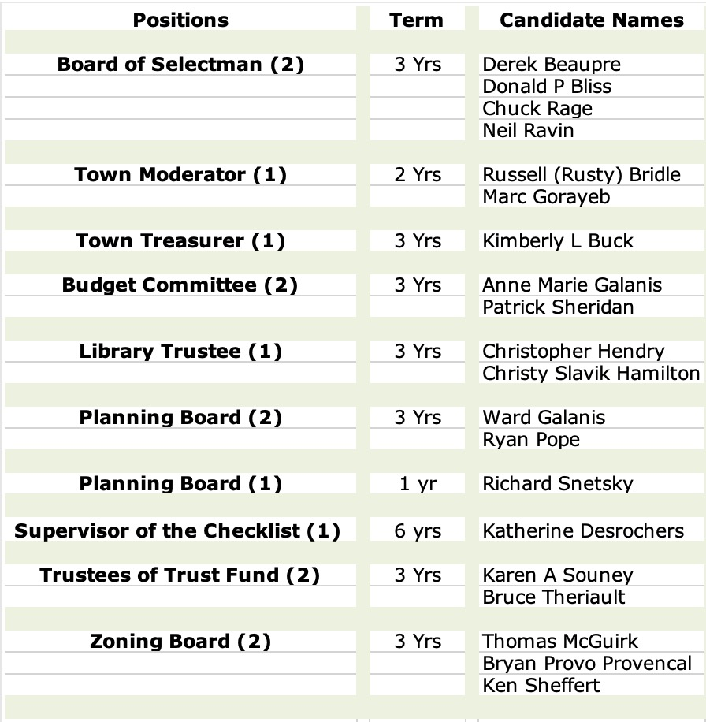

What it means: In 2026, the Board of Selectmen, Town Moderator, Library Trustee and Zoning Board positions have more candidates than openings available. For any opening, you also have the option to write in the name of a candidate. “Non-Partisan ballot” means that in local elections, the candidates do not run with any party affiliation. They run to represent all residents of Hampton.

Articles 2-10 are Zoning Articles and have no direct tax impact.

Article 2 - Easing of Dimensional Standards in the Town Center District

What it means: Within the Town Center District, structural dimensions are being relaxed somewhat in order to encourage more residential building and to thus ease the housing shortage. Differences such as allowing four stories where there once was allowed only three, or removing the requirement that the number of dwelling units per structure should be no more than eight. This could improve the financial outlook for housing development in the Town Center and potentially increase availability of affordable housing.

The changes incorporated in Article 2 are highlighted at this link:

https://intheknowhampton.org/wp-content/uploads/2026/02/httpswww.hamptonnh.govDocumentCenterView11359Article-02-Amendment-1_Town-Center-District-Dimensional-Amendments.pdf

No one spoke for or against this Article at Deliberative Session, other than to explain it.

Article 3 - Cottage Court Ordinance

What it means: Adoption of this Ordinance would add a new overlay district to allow “thoughtful, small-scale residential development”. These would be smaller homes on smaller lots around a shared open space, and with common parking areas to allow for greater density. The goal would be to help alleviate the shortage of housing. These smaller properties would not be allowed under current ordinances.

• Conditional use permit would still be required.
• Not allowed in Residence A and AA or industrial
• Existing perimeter setbacks still apply

The changes incorporated in Article 3 are highlighted at this link:

https://intheknowhampton.org/wp-content/uploads/2026/02/httpswww.hamptonnh.govDocumentCenterView11360Article-03-Amendment-2_Cottage-Court-Ordinance.pdf

No one spoke for or against this Article at Deliberative Session, other than to explain it.

Article 4 - Requirements for “Permanent” and “Temporary” Outdoor Dining Installations

What it means: This Article amends the Zoning Ordinance to clarify and define outdoor permanent and temporary dining areas, since the existing language lacks proper definitions. Establishments that use outside facilities to serve food and beverages must maintain safe and sanitary conditions at all times and ensure outdoor dining installations do not negatively impact public access or surrounding uses.

The changes incorporated in Article 4 are highlighted at this link:

https://intheknowhampton.org/wp-content/uploads/2026/02/httpswww.hamptonnh.govDocumentCenterView11361Article-04-Amendment-3_Outdoor-Dining-Permanent-and-Temporary.pdf

No one spoke for or against this Article at Deliberative Session, other than to explain it.

Article 5 - Replace Accessory Dwelling Unit Ordinance

What it means: Our existing Ordinance related to Accessory Dwelling Units (ADUs) will be deleted in its and replaced by an updated regulation that complies with recent changes in state law. ADU’s no longer need to go through the Planning Department, but require a Building Permit and a Certificate of Occupancy. The owner must live in either the main building or the accessory dwelling. ADU’s are intended for occupancy for no less than 90 days (not for short-term rentals). More details are available at the link below.

https://intheknowhampton.org/wp-content/uploads/2026/02/httpswww.hamptonnh.govDocumentCenterView11362Article-05-Amendment-4_ADU-Ordinance.pdf

No one spoke for or against this Article at Deliberative Session, other than to explain it.

Article 6 - Replace the Solar Energy Systems Ordinance

What it Means: This Article would repeal current Solar Panels Ordinance and replace it with a new Solar Systems Ordinance to define Accessory Use Solar Installation and to:

• Provide comprehensive and current standards for a variety of solar installations
• Add new definitions (heights, setbacks, location on property, co-compliance, emergency access).
• Outline new permitting requirements

No one spoke for or against this Article at Deliberative Session.

The changes incorporated in Article 6 are highlighted here.

https://intheknowhampton.org/wp-content/uploads/2026/02/httpswww.hamptonnh.govDocumentCenterView11363Article-06-Amendment-5_Solar-Energy-Systems-Ordinance.pdf

Article 7 - Modify Parking Space Requirements – Liberty Lane Overlay District

What it Means: This Article amends the Town Zoning Ordinances to comply with NH Statutes as of September 2025. NH Towns and cities are obligated to follow these changes, which reduce the number of parking spaces that a town can require per residential unit.

The changes incorporated in Article 7 are highlighted here.

https://intheknowhampton.org/wp-content/uploads/2026/02/httpswww.hamptonnh.govDocumentCenterView11364Article-07-Amendment-6_Residential-Parking-Changes-per-RSA.pdf

Article 8 - New Telecommunication Facilities Ordinance

What it Means: The proposed changes would bring the Ordinance into alignment with both the Master Plan and State and Federal laws. Approvals will now be based on the appropriateness of the site for the installation, rather than by Zoning District. Among other changes, height restrictions have been modified and would be limited to 130 feet or 125% of the highest point of the mature tree canopy within the area, whichever is less. If there is no mature tree canopy within the subject area, the maximum height shall not exceed 100 feet.
The changes incorporated in Article 8 are highlighted here.

https://intheknowhampton.org/wp-content/uploads/2026/02/httpswww.hamptonnh.govDocumentCenterView11365Article-08-Amendment-7_Telecommunication-Facilities-Ordinance.pdf

Article 9 - Adding a “Home Occupation” Section to the Zoning Ordinance

What it Means: This would amend Article 6, Specific Use Regulations, adding a section on home occupations.

• It adds a definition of Home Occupation
• It provides clarity about activities and uses related to home occupations that may be permitted on residential properties.
• The business owner must reside on premises; product sales are not allowed; services may be provided; one four sq ft sign is permitted, but no other visible/audible indications are allowed; some product type storage prohibited; short-term rentals do not qualify.

In addition to the speaker who explained the Article, one person was opposed to it, unclear about why a ”Home Occupation” needs to be regulated at all. The answer is that if a use is not defined in the Zoning Ordinance, it is prohibited. Because we currently do not have a home occupation ordinance, someone operating a small (residentially appropriate) business from their home could find themselves in a challenging situation. The proposed amendment alleviates the potential for such a situation by providing reasonable standards for home occupation depending on size and intensity, while ensuring the character of residential neighborhoods is protected.

Also, "home occupation" (a small business operated out of the home by the owner/renter) is not the same as "working from home" (completing work tasks provided by an off-site employer at home). The latter is not subject to any form of regulation.

The changes incorporated in Article 9 are highlighted here.

https://intheknowhampton.org/wp-content/uploads/2026/02/httpswww.hamptonnh.govDocumentCenterView11366Article-09-Amendment-8_Home-Occupation.pdf

Article 10 - Exceptions to Construction Provisions for Commercial Facilities

What it Means: The Amendment to this Ordinance states that all Commercial Facilities must be in a permanent structure with a foundation, four walls and a permanent roof. Exceptions are provided for, including seasonal sales and displays, and where a permanent structure has been rendered uninhabitable or demolished due to fire, storm or similar Act of God. The Building Inspector is granted the authority to determine the duration of use for temporary structures and to assure the appropriateness given surrounding property uses.

The changes incorporated in Article 10 are highlighted here.

https://intheknowhampton.org/wp-content/uploads/2026/02/httpswww.hamptonnh.govDocumentCenterView11367Article-10-Amendment-9_Commercial-Uses-in-Buildings.pdf

Articles 11-36 are Town-Sponsored Articles

How much will approval of a specific article cost for my tax bill? Taxes are calculated based on the valuation of your real estate property. Throughout this document, the cost is translated for perspective for a homeowner of a property valued at $600,000.

If you want to see the cost for your specific property: Get your valuation from your latest tax bill. Go to Calculator on the Town’s website: https://www.hamptonnh.gov/738/Warrant-Article-Calculators Enter your home’s value, and the see the cost for a single Article or for all Warrant Articles.

Article 11 - Aerial Ladder Fire Apparatus via Long Term Lease/Purchase - $1,800,000

To see if the Town will vote to authorize the Select Board to enter into a long-term lease/purchase agreement in the amount of $1,800,000 payable over a term of seven annual payments for the purpose of acquiring an Aerial Ladder Fire Apparatus and all related equipment, and to raise and appropriate the sum of $308,712 for the first year’s payment for that purpose. (3/5^{ths} Ballot vote required)

What it means: The Town would enter into a seven-year lease for the fire equipment; at the end of this time, the Town would own the ladder truck. Because the Town would enter into a multi-year arrangement (essentially obligating future groups of taxpayers), a 60% approval by the voters is required by state law.

Discussion: The ladder to be replaced is a 2006 vehicle, with a 20-25 year life expectancy. It takes two to four years to order and receive the new vehicle. The current vehicle is costing more to maintain and has corrosion issues due to our marine environment. If approved by Town Meeting, the Fire Chief would search for the best vehicle to meet the needs of the Town. The maximum budget is the $1.8 million that is listed.

The current ladder truck cost taxpayers $135,000 in repairs in the last five years alone and over $375,000 over the 20-year ownership span.

Fiscal impact: The estimated tax rate impact in 2026 for first lease payment is $0.05 per thousand. The estimated tax impact for a home valued at $600,000 is $30.41. This obligation would continue until 2032.

Article 12 - Copper Compliance and Outfall Study Phase II - $100,000

To see if the Town of Hampton will vote to raise and appropriate the sum of $100,000 for the purpose of performing a Copper Compliance and Outfall Study Phase II to include additional investigation and studies in accordance with the Phase I Copper Compliance and Outfall Study recommendations. The Town was issued an Administrative Order on Consent (AOC) in March 2022 by the EPA to address non-compliance with the total copper WWTF discharge limits. As a result of the AOC and based on the results of the original pilot test using chemicals, and the Phase I findings, the Town has been evaluating other alternatives for compliance with total copper WWTF discharge limits. Phase II will include dye studies and additional investigation in an outfall relocation.

Said appropriation to be offset by $100,000 in principal loan forgiveness under the New Hampshire Department of Environmental Services Clean Water State Revolving Fund (SRF); and

to authorize participation in the State Revolving Fund (SRF) (RSA 486:14) established for the purpose, and to authorize the Select Board to accept and expend such monies as they become available from the Federal and State Governments.
This shall be a non-lapsing appropriation per RSA 32:7, VI and shall not lapse until the project is completed or by March 31, 2031, whichever occurs sooner. (3/5^{ths} Ballot vote required)
What it Means: Hampton was issued an Administrative Order of Non-Compliance from EPA in 2022 regarding Wastewater Treatment Facility discharge of total copper beyond allowable limits. This is damaging to aquatic life. The Town is required to take corrective action. This study allows the Town to understand the causes of the higher amount of copper, and to investigate potential solutions. Phase 1 was completed and approved in 2025. Phase 2 will include dye studies and additional investigation regarding the possibility of outfall relocation. To be offset by $100K in principal loan forgiveness under the NH Dept. of Environmental Services Clean Water State Revolving Fund.

No one spoke for or against this Article at Deliberative Session, other than to explain it. However, someone asked - if funds are being raised for this purpose, and then we get reimbursed, what happens to the funds at the time of reimbursement? The answer is that if the funds come in the same year, then it is a “wash” – meaning that the extra revenue does not have to be raised by taxes. If the reimbursement is in a subsequent year, the reimbursement revenue is added to the General Fund to offset taxes in the subsequent year.
Fiscal impact: The estimated tax rate impact in 2026 is $0.02 per thousand. The estimated tax impact for a home valued at $600,000 is $9.85.

Article 13 - Operating Budget of $38,236,520 versus a Default Budget of $37,778,312

To see if the Town of Hampton will vote to raise and appropriate as an operating budget, not including appropriations by special warrant articles and other appropriations voted separately, the amounts set forth on the budget posted with the warrant as amended by vote of the first session, for the purposes set forth therein, totaling $38,236,520. Should this article be defeated, the default budget shall be $37,748,568 which is the same as last year, with certain adjustments required by previous action of the Town of Hampton or by law; or the governing body may hold one special meeting, in accordance with RSA 40:13, X and XVI, to take up the issue of a revised operating budget only.

What it means: The voters are presented with two possible operating budgets. The Proposed Operating Budget is what the Town departments feel they need to manage the Town efficiently, safely and effectively. The Default Budget is a calculated budget defined by RSAs (New Hampshire state legislature), which specify certain costs that must be covered in the Town’s Budget. Both budgets for 2026 reflect cost of Warrant Articles approved at prior Town Elections. The difference between the two budgets is $487,952.

A default budget is regulated by RSA 40:13 and starts with the prior year’s approved budget, and is increased by obligations mandated by law; debt service and contracts lawfully entered into; and is reduced by one-time expenditures, salaries and benefits related to positions that may have been eliminated. The Default Budget will be the operating budget for the Town in the event the Proposed Operating Budget fails to pass. 80% of both the Proposed Operating Budget and the Default Budget is driven by wages, benefits, contracts and debt. The Proposed Operating Budget represents a 5.26% increase over the 2025 approved Operating Budget. The Default Budget represents a 4% increase.

Those in favor say: The Budget Committee worked with each Town department to review needs and obligations. Each line item of the budget was thoroughly reviewed by the Department Heads, Board of Selectmen, Town Manager and the Budget Committee. The Proposed Operating Budget funds what is necessary to maintain the current level of services to the Town while reducing costs where possible. The Proposed Operating Budget includes a 3% increase in wages for non-union employees. Other cost increases include computer software upgrades, IT support fees, and the leasing of two trash trucks for use during the summer months.
Those opposed say: One speaker noted that in review of the 2025 expenses, there was $2.2M of unspent funds from the 2025 approved Operating Budget. A proposal at Deliberative Session to cut the Proposed Operating Budget by 2% was defeated. Those who spoke against the Proposed Operating Budget expressed praise for the level of services the Town provides but noted that care needs to be taken not to tax people out of their homes.

Fiscal impact: The estimated additional tax rate impact for the 2026 Budget is $0.31 per thousand. The estimated tax impact for a home valued at $600,000 is $188.12. The estimated additional tax rate impact for the Default Budget is $0.24 per thousand. The estimated tax impact for a home valued at $600,000 is $142.98.
If the Proposed Operating Budget passes, the additional cost will be $45.15 for that $600,000 property.

Article 14 - Improvements to Public Streets & Sidewalks - $950,000 with a Partial Offset

To see if the Town of Hampton will vote to raise and appropriate the sum of $950,000 for the purpose of improvements to streets, sidewalks, and driveway openings; replacements to drainage and/or sewers; curbing maintenance or installation; and improvements and repairs to Town parking lots, parking areas, and cemeteries. Said appropriation to be offset by the State Highway Block Grant estimated to be $332,750. Any remaining balance after receipt of any grant funds shall be raised through taxation. This shall be a non-lapsing appropriation per RSA 32:7, VI and shall not lapse until the improvements are completed or by March 31, 2031, whichever occurs sooner.

What it Means: Hampton anticipates receiving a NH DOT Highway Grant for $332,750 to help maintain Class IV and Class V “highways” (compact sections of town roads). Funds are applied to specific projects identified by DPW and approved by the Board of Selectmen. Taxpayer funding is used to supplement the Highway Block Grant provided by the State to improve Town Roadway Networks (including paving). The focus for 2026 funds will be Lafayette Road, based on its condition and heavy use. PCI is a rating system for the condition of a road, which is scored between 0 and 100, with 100 being a perfect surface. Lafayette Road has a Pavement Condition Index (PCI) of 46. Hampton’s overall PCI is 71.

Note: The project identified for this Grant project last year included the travel lanes of Lafayette Road. However, work to Mace Road preempted that work. The 2026 plan is to pave the entire width of Lafayette Road including the center lane, and also to do sidewalk work on Route 101 for ADA compliance.

No one spoke for or against this Article at Deliberative Session, other than to explain it.
Fiscal impact: The estimated tax rate impact in 2026 is $0.10 per thousand. The estimated tax impact for a home valued at $600,000 is $60.81.

Article 15 - Road Improvement Capital Reserve Fund $750,000

To see if the Town will vote to raise and appropriate the sum of $750,000 for the purpose of adding to the Road Improvement Capital Reserve Fund previously established under Article 16 of the 1998 Annual Town Meeting.

What it means: $750K will be added to the Road Improvement Capital Reserve Fund. This is essentially a savings account that allows the Town to plan needed road work without having to ask for all of the needed funds in one tax year. Although the funds accumulate, they may not be spent except by approval of the voters via warrant articles at Town Meeting.

No one spoke for or against this Article at Deliberative Session, other than to explain it.

Fiscal impact: The estimated tax rate impact in 2026 is $0.12 per thousand. The estimated tax impact for a home valued at $600,000 is $73.89.

Article 16 - Repairs to the Exeter Road Culvert and Structures - $624,500 (From Existing Fund)

To see if the Town of Hampton will vote to raise and appropriate the sum of $624,500 for the purpose of repairing the culvert crossing Exeter Road, constructing a new headwall, and conducting stream/bank erosion control; and to authorize the withdrawal of $624,500 from the Road Improvement Capital Reserve Fund. This funding will support the design, engineering, construction, replacement, and other associated items of the project identified as needing work. This will be a non-lapsing appropriation per RSA 32:7 VI and shall not lapse until the work is completed or by March 31, 2031, whichever is sooner.

What it Means: There is a deteriorating culvert that runs under Exeter Rd, where there is a north-to-south running stream. The current failure of the culvert is eroding the bank, ruining vegetation and destroying the yard of an adjacent property. The funds needed to assess, consult and implement repairs to the culvert would be withdrawn from the Road Improvement Capital Reserve Fund.

No one spoke for or against this Article at Deliberative Session, other than to explain it.

Fiscal impact: No tax impact; money will be withdrawn from the Road Improvement Capital Reserve Fund.

Articles 17, 18, 21, 23, 25, 26 and 27 if approved, will draw upon the Unassigned Fund Balance or “UFB” and reduce taxpayer cost in the current year by $879,753 - roughly $86.66 savings for a home valued at $600,000.

The Unassigned Fund Balance consists of excess funding that comes from either more revenues than expected (Example: the Rooms and Meals Tax distribution from the State; or higher than anticipated revenues from a Trust Fund) OR from lower than anticipated costs (example an expense approved by the taxpayers that ends up not costing as much as raised, or the project is not pursued.)

There is a required minimum funding that a municipality needs to maintain in the Unassigned Fund. The New Hampshire Department of Revenue Administration (DRA) recommends 5%-17% of the municipality’s overall budget be held as “unassigned” to cover emergencies and to mitigate the fluctuations in the timing of revenue received and outlays required. Hampton tends to stay on the lower end of the range. When there is excess funding beyond these hold-back requirements, the voters have the option to approve or not approve the use of the funds to pay for projects the Town Departments feel are needed. If the voters want these projects and if they were NOT being funded by the Unassigned Fund Balance, it would require additional taxation.

The UFB is still in flux, as 2025 numbers are not fully finalized and the auditors have yet to review the books. The value, however is estimated at just under $7.5 million. If all the Articles that call upon the Unassigned Fund Balance are passed, it would reduce the UFB to just over $6.5 million, which would leave adequate backup resources, and allow the town to qualify for lower bond rates when needed.

When you see “no tax impact in 2026” associated with an Article that uses the Unassigned Fund Balance, it means there is no need to raise new tax revenue to cover the proposed costs, because the money was previously raised, earned or conserved. However, the voters have the ability to approve or reject the proposed use of those funds.

Article 17 - Freightliner Refuse Collection Truck - $412,666 (from Grant Money and from UFB)

To see if the Town of Hampton will vote to raise and appropriate the sum of $431,000 for the purpose of purchasing a Freightliner Refuse Collection Truck with dual articulating arms including all associated equipment to put the vehicle in service. The new vehicle will replace a 2006 Diesel Rear Loader. Said appropriation to be offset by the Granite State Clean Fleets reimbursement program for projects that propose to reduce diesel emissions and is estimated to be 80% of the vehicle’s cost ($330,133), and the remainder ($100,867) to come from the Unassigned Fund Balance. The replaced vehicle to be scrapped or sold, whichever is most beneficial to the Town as determined by the Town Manager and Director of Public Works. This shall be a non-lapsing appropriation per RSA 32:7, VI and shall not lapse until the purchase is completed or by March 31, 2031, whichever is sooner.

What it means: The new trash vehicle will be purchased with funds that come 80% from a grant, and 20% from the Unassigned Fund Balance. As with other specialty vehicles, the lead time is such that the Town may still need to wait for delivery.

Those in favor say: The Town has struggled with the lack of functioning sufficient trash collection trucks. Some of the trucks in the fleet are simply not reliable, and the vehicle to be replaced is a rear loader, whereas the more efficient trucks have the wing arms for automated pickup.

Those opposed say: No one spoke against this Article at Deliberative Session.

Fiscal impact: No tax impact in 2026, as the funds will be a combination of grant money ($330,133) and a withdrawal from the Unassigned Fund Balance ($82,533).

Article 18 - Three DPW Trucks - $ 349,220 - UFB

To see if the Town of Hampton will vote to raise and appropriate the sum of $385,940 for the purpose of purchasing three items; a trailer for transporting refuse; a one-ton truck with plow, wing and spreader; and a ¾ ton truck with plow; including all associated equipment to put said vehicles in service. Said funds of $385,940 to come from the Unassigned Fund Balance. The replaced vehicle(s) to be traded in or sold as deemed to be prudent by the Public Works Director, Town Manager, and the Select Board. This shall be a non-lapsing appropriation per RSA 32:7, VI and shall not lapse until the purchase is completed or by March 31, 2031, whichever is sooner.

What it means: DPW is requesting a refuse transportation trailer, a ¾-ton truck with plow, and a one-ton truck with wing and plow. Each of these are currently part of the fleet, and all of them have condition issues. The funding will come from the Unassigned Fund Balance.

Those in favor say: These vehicles are needed to provide the services that the Town needs and expects. Six of the seven trailers that DPW has in the fleet are from 2012 and there have been multiple mechanical issues that the department has been able to repair in order to maintain the storage and transport capacity. The existing ¾-ton truck has been taken out of service due to a cracked frame. The one-ton truck is from 2004 and is no longer usable for wing operations. This equipment is needed to provide the expected services.

Those opposed say: No one spoke against this Article at Deliberative Session.

Fiscal impact: No tax impact in 2026, as the funds would be withdrawn from the Unassigned Fund Balance.

Article 19 - Parks and Recreation Department 14 - Passenger Bus with Wheelchair Lift - $ 220,000

To see if the Town of Hampton will vote to raise and appropriate the sum of $220,000 for the Parks and Recreation Department to purchase a 14-passenger bus with wheelchair lift, for transportation to Recreation-sponsored events; and to purchase a heavy-duty 4WD pick-up truck with plow; and to contribute to the repair, replacement, service or maintenance of the fields, grounds and equipment, as determined to be in the best interests of the Town, and to authorize the withdrawal of said sum of $220,000 from the Hampton Recreation Infrastructure Special Revenue Fund previously established under Article 44 of the 2007 Annual Town Meeting. This shall be a non-lapsing appropriation per RSA 32:7, VI and shall not lapse until the improvements are completed or by March 31, 2031, whichever occurs sooner.

What it Means: This Article seeks to use funds from the Hampton Recreational Infrastructure Special Reserve Fund established in 2007, to replace two existing vehicles used by the Parks and Recreation Department, which are aging and have become costly to repair. The van to be replaced is a 2015 bus which is having electrical and transmission issues. The truck is used to maintain all the fields and facilities and is also experiencing transmission problems.

Those in favor say: There was general support expressed for the Parks and Recreation Department. It was also noted that 20% of the parking revenue from municipal lots helps to fund the Hampton Recreational Infrastructure Special Reserve Fund, so there is no need to raise taxes for these purchases.

No one spoke against this Article at Deliberative Session.

Fiscal impact: There is no tax impact, as the funds are put aside for this purpose and only need voter approval for the intended use.

Article 20 - Donation to Agencies Based on Services Provided to Hampton Residents - $176,611

To see if the Town of Hampton will vote to raise and appropriate the sum of $176,611 for the purpose of funding the following twenty-one (21) human service agencies in the Seacoast area in the amounts requested for 2026. These agencies shall be required to give a written report at the end of their fiscal year 2026 to the Select Board highlighting what the funds were used for and what impact the funds had in assisting them to achieve their goals and objectives. (Chart of agencies and amounts on the next page.

What it means: This article asks voters to approve funding for a group of nonprofit human service agencies serving Hampton. The Town’s contribution helps support programs that provide food assistance, housing support, health services, family services, senior services, and related community-based support that might otherwise fall to the Town’s Welfare Department. The amount asked is exactly the same as in 2025 for all agencies. All dollar amounts have been derived based upon the number of Hampton residents who are served.

Fiscal impact: The estimated tax rate impact in 2026 is $0.01 per thousand. The estimated tax impact for a home valued at $600,000 is $8.13.
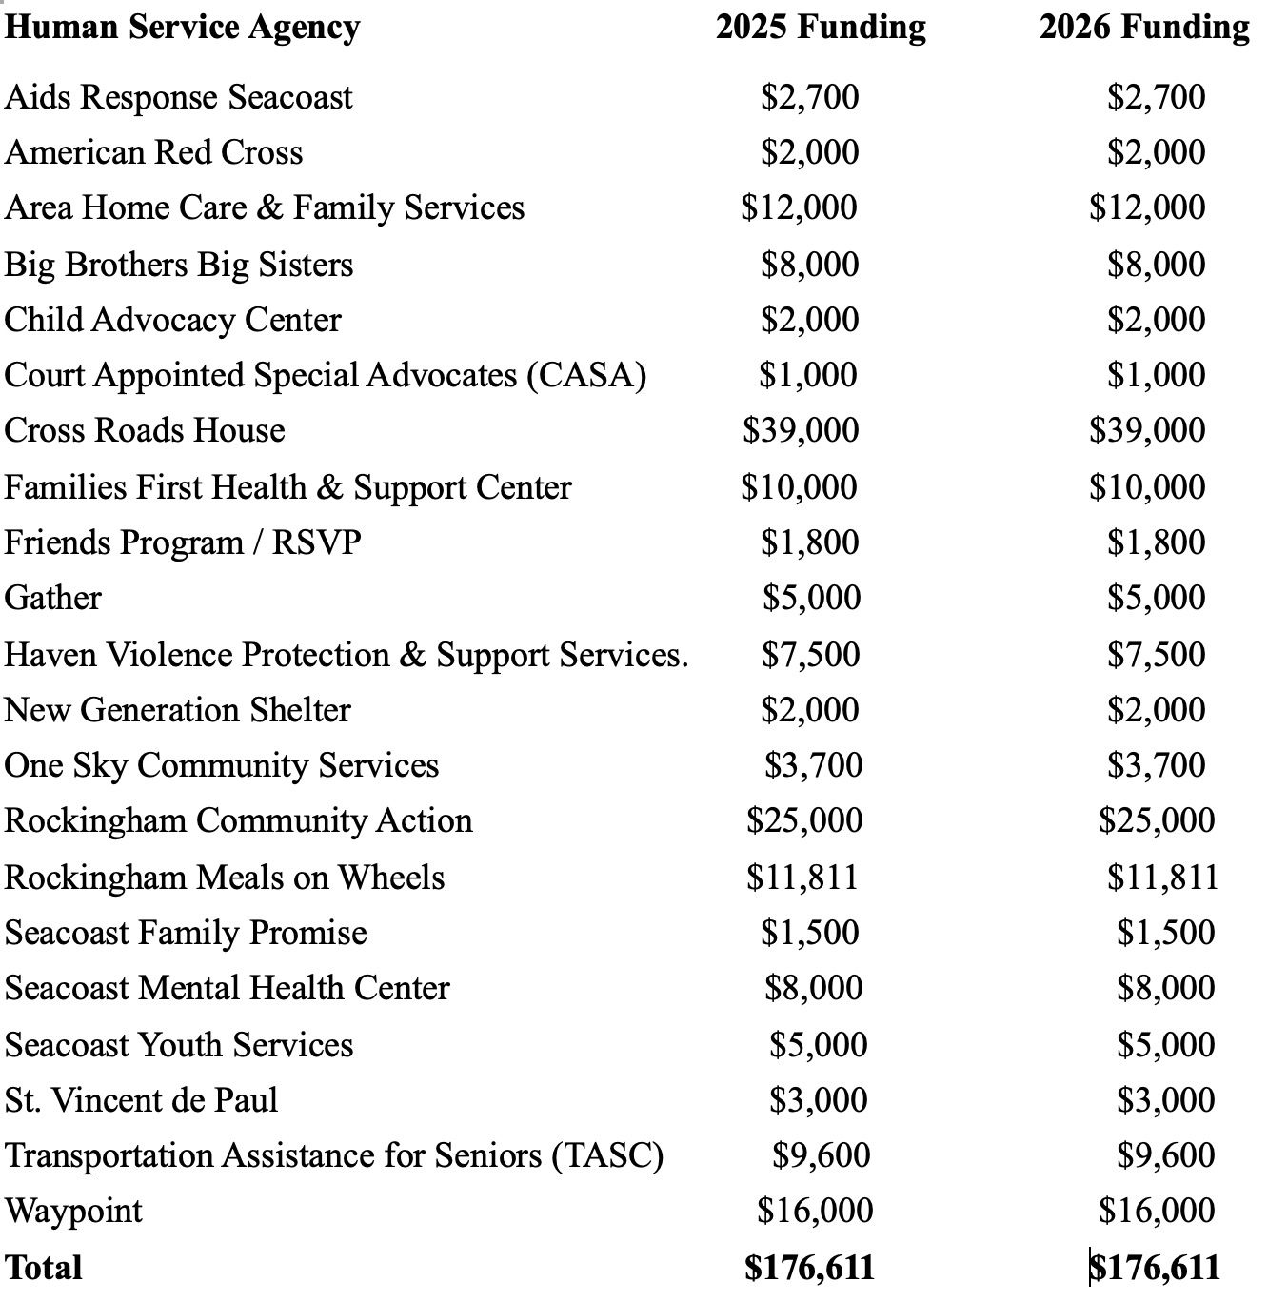

Article 21 - Capacity Yard Truck - $153,000 - UFB

To see if the Town of Hampton will vote to raise and appropriate the sum of $153,000 for the purpose of purchasing a Capacity Yard Truck, including all associated equipment to put the vehicle in service, said funds to come from the Unassigned Fund Balance. The new vehicle will replace a 2007 Diesel Yard Truck which is used daily, year-round, to move the trash and recycling trailers. This shall be a non-lapsing appropriation per RSA 32:7, VI and shall not lapse until the purchase is completed or by March 31, 2031, whichever is sooner.

What it means: The new vehicle will replace a 2007 Diesel Yard Truck which is used everyday, year-round, to move the trash and recycling trailers.

Those in favor say: Recent repairs include alternator, ignition switch, circuit board and pressure system. The new vehicle will have a hydraulic connection to push or move loads. Without hydraulics currently, other equipment needs to be used to accomplish the task, thus requiring more involvement from personnel.

No one spoke against this Article at Deliberative Session.

Fiscal impact: No tax impact in 2026, as the funds would be withdrawn from the Unassigned Fund Balance.

Article 22 - Hire an Economic Development Director - $121,578 in 2026 ($162,018 thereafter)

To see if the Town of Hampton will vote to raise and appropriate the sum of $121,578, including salary and benefits, for the purpose of employing an Economic Development Director to advance Hampton’s Master Plan, coordinate communications, secure and manage grants, and foster partnerships with businesses, not-for-profits, developers, and state agencies, starting on April 1, 2026? The estimated full year cost in 2027 for this position is $162,018, including salary and benefits; all future costs for this position will be included in Town operating budget and default budget going forward.

What it means: This Article asks to create a new position of Economic Development Director to manage and advance the implementation of Hampton’s Master Plan and work to increase non-residential sources of tax revenue. Currently, interactions with potential developers are spread among the Town’s departments. The job description can be found here:
https://intheknowhampton.org/wp-content/uploads/2026/02/2026-Article-22Economic-Development-Director-2.pdf

Those in favor say: This position will be the interface between the Town Departments and prospective developers and businesses, and will help increase the value of business presence in Hampton. It was expressed that this position would result in the expansion of the Town’s commercial presence, to ease the tax burden on residential properties (which currently account for 90% of the tax base). Other towns have established this position, and have experienced positive growth to tax revenue from business properties. Hampton won’t know what the offsets might be until it is tried.

Those opposed say: It was expressed that this was a good idea but that the job description was too vague and perhaps not ready to implement. The cost could easily grow with the need for support staff for the position. It was also noted that land for development in Hampton is scarce and that recent proposals to develop or redevelop were met with resistance from residents. One person said that more data is needed to justify the added headcount.

Fiscal impact: The estimated tax rate impact in 2026 is roughly $.02 per thousand. The estimated tax impact for a home valued at $600,000 is $11.98. Thereafter, the costs of salaries and benefits would be included in future proposed and default budgets.

Article 23 - Capital Reserve Fund – Maintenance of Town Buildings - $100,000 - UFB

To see if the Town of Hampton will vote to raise and appropriate the sum of $100,000 for the purpose of adding to the Municipal Buildings Capital Reserve Fund previously established under Article 22 of the 2025 Town Meeting. Said sum of $100,000 to come from the Unassigned Fund Balance.

What it means: The Article is asking to add funds to a Capital Reserve Fund (CRF) that was established in 2025 specifically for maintaining, repairing and upgrading town-owned buildings. The intention is to have the funds for needed repairs or upkeep, and the Board of Selectmen have been named as agents – meaning that they can make withdrawals as needed. The $100,000 that will be deposited to this CRF would come from the Unassigned Fund Balance, and would not have a fiscal impact in 2026.

No one spoke for or against this Article at Deliberative Session, other than to explain it.

Fiscal impact: No tax impact in 2026, as the funds would be withdrawn from the Unassigned Fund Balance.

Article 24 - Police Forfeiture Fund - $90,000 (No Tax Impact)

To see if the Town of Hampton will vote to raise and appropriate the sum of $90,000 for the purpose of conducting all lawful functions allowed under federal, state, and local criminal justice forfeiture programs and to authorize the withdrawal of said sum of $90,000 from the Police Forfeiture Special Revenue Fund previously established under Article 55 of the 2003 Town Meeting.

What it means: During police operations, items of value may be forfeited by individuals. NH law permits the auctioning of abandoned property, and the proceeds are put into a fund. This Article would allow the funds to be withdrawn to cover departmental costs, as approved via the RSAs. The actual amount is unknown at voting time. The $90,000 is seen as the upper limit of what may be available to withdraw.

No one spoke for or against this Article at Deliberative Session, other than to explain it.

Fiscal impact: There would be no tax impact, since this money is in a set-aside fund. This is a routine measure to allow the withdrawal of the funds for various Police Department needs.

Article 25 – Ann’s Terrace Drainage Study - $80,000 - UFB

To see if the Town of Hampton will vote to raise and appropriate the sum of $80,000 for the purpose of conducting a survey and preliminary design of a new drainage system in the area of Ann’s Terrace for the purpose of alleviating flooding and creating a drainage system that does not currently exist, said funds to come from the Unassigned Fund Balance. This will be a non-lapsing appropriation per RSA 32:7 VI and shall not lapse until the work is completed or by March 31, 2031, whichever is sooner.

What it means: This Article seeks to fund a survey and preliminary design for a drainage system for the area of Ann’s Terrace which currently has no municipal drainage system.

Those in favor say: Ann’s Terrace is not located in a flood zone but basements and garages routinely flood from the run-off waters and snow melt. Long-term residents have seen flooding conditions worsen with more intense storms, continued development and granted variances, adversely affecting an already-strained drainage area that has no municipal drainage system. Residents have done what they can by preserving natural drainage paths, maintaining French drains and using sand bags. Municipal drainage would benefit residents of the entire area including Ann’s Lane and Dearborn Ave.

No one spoke against this Article at Deliberative Session

Fiscal impact: No tax impact in 2026, as the funds would be withdrawn from the Unassigned Fund Balance.

Article 26 - Department of Public Works Site Facility Study - $75,000 - UFB

To see if the Town of Hampton will vote to raise and appropriate the sum of $75,000 for the purpose of preparing a Department of Public Works Site Facility Study, said funds to come from the Unassigned Fund Balance. Professional consulting services will be retained related to the preliminary design of a new Public Works administrative and maintenance facility including upgrades to the transfer station building and the re-purposing of the existing site features for storage and to provide the much-needed flood protection. The study will include a space needs analysis, site analysis, building reuse/renovation recommendations (if practical), preliminary conceptual design alternatives and associated opinions of cost. This will be a non-lapsing appropriation per RSA 32:7 VI and shall not lapse until the work is completed or by March 31, 2031, whichever is sooner.
What it means: This funding would support a study into the needs of the DPW administrative and maintenance
areas. The goal is to reorganize, upgrade and provide flood protection for the vehicles. A consulting firm would be hired to identify options for accomplishing the needs of the Department and the Town. The study funds would be taken from the Unassigned Fund Balance.

Those in favor say: The buildings on the DPW site are deteriorating, are insufficient for current needs and do not provide a flood-protected environment with sufficient warmth so the equipment is ready to go when the conditions require DPW to act on behalf of the Town. These upgrades are badly needed and are long overdue.

Those Opposed Say: No one spoke in opposition to this Article at Deliberative Session.

Fiscal impact: No tax impact in 2026, as the funds would be withdrawn from the Unassigned Fund Balance.

Article 27: Firefighters Turn Out Gear Capital Reserve Fund – $40,000 - UFB

To see if the Town of Hampton will vote to raise and appropriate the sum of $40,000 for the purpose of adding to the Firefighters Turn Out Gear/Personal Protective Equipment Capital Reserve Fund previously established under Article 17 of the 2019 Town Meeting. Said sum of $40,000 to come from the Unassigned Fund Balance.

What it means: In 2019, voters approved $200,000 for a new Capital Reserve Fund for the replacement of Firefighter’s Protective Gear. As gear is replaced using money withdrawn from the fund, additional funds are needed for the next round of replacements. This Article would transfer the funds from the Unassigned Fund Balance to the Turnout Gear Reserve Fund.

Those in favor say: This is an annual procedure to keep our Firefighters safe. A single set of firefighting gear costs upwards of $6,000. There are strict standards with regard to the amount of service before the gear must be replaced, and that has meant four to five new sets of equipment each year. To cover this expense, a reserve fund was established in 2019 and needs to be regularly replenished.

Fiscal impact: No tax impact in 2026, as the funds would be withdrawn from the Unassigned Fund Balance.

Article 28 – Hampton Conservation Fund - $30,000

Shall the Town of Hampton vote to raise and appropriate the sum of $30,000 to be placed in the Hampton Conservation Fund? This Fund is used to “acquire, maintain, improve, protect or limit the future use of, or otherwise conserve and properly utilize,” open spaces and conservation easements in Hampton in accordance with RSA 36-A:4.

What it Means: This Fund is used by the Conservation Commission to protect open spaces via acquisition or conservation easements, on behalf of the Town. This Warrant Article helps to build the Fund so that it can be used to pay for future conservation opportunities as they are identified. Examples of recent uses of the fund include the 2022 purchase of the Barkley Property and the establishment of a conservation easement there, and the 2019 establishment of a Conservation Easement on the Batchelder Farm. The Commission tries to build up this Fund gradually to help reduce, if not eliminate the need to ask the voters for additional dollars when conservation opportunities arise.
No one spoke for or against this Article at Deliberative Session, other than to explain it.

Fiscal impact: The estimated tax rate impact in 2026 is less than $0.01 per thousand. The estimated tax impact
for a home valued at $600,000 is $2.96.
Article 29 – Changes to the Cemetery Maintenance Trust Fund 2/3rd Vote Required – No Tax Impact

To see if the Town will vote to change the existing Cemetery Maintenance Trust Fund, created in 1986 pursuant to RSA 31:19-a and amended in 2016, to the Cemetery Maintenance Capital Improvements and Expansion Trust Fund, to be administered by the Trustees of the Trust Fund; and to further authorize the Select Board as agents to expend principal and income from this fund. (2/3^{rds} Ballot vote required)

What it means: This fund was initiated in 1986 under the title of the “Cemetery Burial Trust Fund” for the maintenance of Town-owned cemeteries. In 2016, the name was changed to “Cemetery Maintenance Trust Fund,” and allowed the legislative body (voters at Town Meeting) to make expenditures from both the principal and the interest in the Fund. The current question asks whether the Fund can be used to expand the capacity of the cemeteries (in addition to maintenance) and it changes the authority for making withdrawals from the voters to the Board of Selectmen. Note that because this is a change to a Trust Fund, 67% approval by the voters is required to pass.

No one spoke for or against this Article at Deliberative Session, other than to explain it.

Fiscal impact: No immediate tax impact. However, if the principal is depleted by virtue of the broader definition of the purpose of the Fund, future maintenance expenditures may need to be covered by other sources of revenue, such as taxes.

Article 30 – Capital Reserve Fund Municipal Transportation Improvement Fund

To see if the Town will vote to adopt the provisions of NH RSA 261:153 (VI) to levy an additional motor vehicle registration fee in the amount of $5.00 to support a municipal fund for improvements in the local or regional transportation system including roads, bridges, bicycle and pedestrian facilities, electric vehicle charging stations, parking and intermodal facilities, and public transportation. With the adoption of this article the Town shall establish a Capital Reserve Fund pursuant to RSA Chapter 35 to be known as the Municipal Transportation Improvement Fund, and to name the Select Board as agents to expend. The funds may be used for engineering, right-of-way acquisition, and constructions costs of transportation facilities, and for operating and capital costs of public transportation only. The funds may be used as matching funds for state or federal funds allocated for local or regional transportation improvements and shall not be used to offset any other non-transportation appropriations made by the Town.

What it means: This Article proposes a $5.00 surcharge on motor vehicle registrations to be deposited into a new Capital Reserve Fund that would support transportation needs including roads, bridges, bicycle and pedestrian facilities, electric vehicle charging stations, parking and intermodal facilities, and public transportation.

Fiscal Impact: There is no property tax impact for this Article, but an additional $5.00 would be collected each time you register a vehicle.

Article 31 – Long-Term Lease Agreement re: Solar Array on the Capped Landfill

Shall the Town authorize the Select Board to enter into a long-term lease agreement for up to twenty (20) years with Kearsarge Solar LLC, or its successors or assignees, to lease a portion of Town-owned property located on Hardart’s Way (constituting the closed, capped Town landfill) for the construction, installation, and operation of a solar array, on such terms and conditions as determined by the Select Board and to authorize the Select Board to take any other actions necessary to carry out this vote.
Further, to see if the Town shall vote to authorize the Select Board to negotiate and execute a net metering agreement, PILOT (Payment in Lieu of Taxes), and such other agreements related and incidental to the lease of the parcel for that purpose on such terms as the Select Board deems reasonable.

What it means: The Town has the opportunity to lease the closed capped Town landfill on Hardart’s Way, for the purpose of constructing and installing a solar array which would benefit the Town with revenue from Kearsarge Solar LLC (the lessee). In addition, the Town could negotiate a net metering agreement with the lessee to share in the benefits of the electricity generated by the solar panels to help reduce the cost of electricity required by DPW.

Those in favor say: Those in favor pointed out that this is an opportunity to take advantage of the unused Town-owned land. There would be two positive impacts on the budget - the lease revenue and the potential of an offset to electricity costs for DPW.

Those opposed say: There was no opposition to this Article, but concerns were expressed about costs of maintaining the panels, as well as possible damage to the membrane to the covered landfill that could cause gasses to escape. The response to this concern was that the agreement would include provisions that these responsibilities and associated costs would be borne by the leasing party, not the Town.

Fiscal impact: No immediate tax impact. There is a possibility of expense offsets and/or revenue in the future.

Article 32 – Increase the Optional Tax Credit for a Service-Connected Total Disability

To see if the town will vote to increase the optional tax credit for a Service-Connected Total Disability currently at $4,000 to $4,750 on residential property per the provisions of RSA 72:35.

What it means: Previously, Veterans with a Service-Related Permanent Disability or surviving spouses could qualify for both a standard tax credit and an optional tax credit. Recent changes in state law dictate that only one can be claimed, not both. To keep Veterans from losing part of their previous property tax credits, towns including Hampton are proposing to increase the optional credit from $4,000 to $4,750. There is no significant tax impact because one type of cost easement is being substituted for another.

No one spoke for or against this Article at Deliberative Session, other than to explain it.

Fiscal impact: There would be no significant tax impact because theoretically, one type of cost easement is being substituted for another.

Article 33 – Proposed Increase in Qualifying Income for Elderly Property Tax Exemption

To see if the Town will amend the Elderly (Property Tax) Exemption program of RSA 72:39-a as previously adopted in the Town of Hampton, based on assessed value for qualified taxpayers, to be as follows: for a person 65 years of age up to 75 years, $175,000; for a person 75 years of age up to 80 years, $225,000; for a person 80 years of age or older, $300,000. To qualify, the person must have been a New Hampshire resident for at least 3 consecutive years, own the real estate individually or jointly, or if the real estate is owned by such person’s spouse, they must have been married to each other for at least 5 consecutive years. In addition, the taxpayer must have a net income of not more than $50,000, or if married, a combined net income of not more than $90,000; and own net assets not in excess of $250,000, excluding the value of the person’s residence. The purpose of this article is to change only the net income thresholds to qualify. Should this article not pass, the net income amounts for the Town’s elderly exemption from property tax shall remain as previously established.
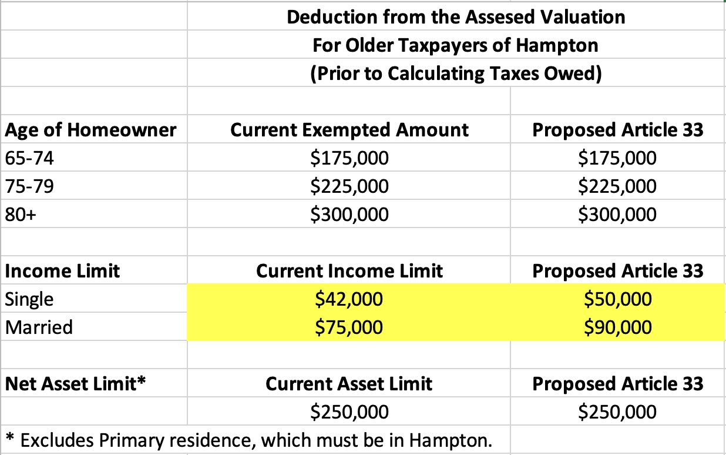
What it Means: In Hampton (as in many towns), we have real estate tax exemptions that are granted to lower-income older residents to assist with their tax burden, to allow them to remain in their homes. The way it works is the amounts referenced in the chart below are taken off the assessed value of the home prior to calculating the taxes for that property. There are net income and net asset limitations, since the program is meant to help those in need. Currently, older taxpayers can earn no more than $42,000 for one person or $75,000 for a married couple in order to qualify for this exemption. The exemption deducts between $175,000 to $300,000 (depending on age) from the property valuation before taxes are calculated. If this Article passes, single qualifying homeowners would be able to earn up to $50,000 per year and a married couple could bring in up to $90,000 a year. That increase is roughly 20% higher than the previous qualifying income limit.
`

Those in favor say: The income limit to qualify for the Elderly Property Tax Exemption has only been increased once in 25 years for 15%, during a span of time during which inflation has gone up 75%. This Article will help prevent older taxpayers from having to sell their homes if they can’t keep up with the rate of increases on property taxes.

Those opposed say: The population group of 65+ is going to double by some estimates in the next 20 years. The more exemptions that we allow, the more the tax burden shifts to younger people who are also just trying to make ends meet. The income level was just increased via Article 29 in 2024. At that time, the income qualification for a single taxpayer was raised from $38,000 to $42,000 (10% increase) and for married taxpayers, it increased from $58,000 to $75,000 (29% increase). The increases proposed this year would be on top of the 2024 increase.

Fiscal Impact: A speaker at Deliberative Session stated that only three additional Elderly Exemption applications were received at Town Hall after the 2024 increase, however it is not known how many taxpayers will apply for the exemption with the new increases in place. For fiscal perspective, in 2022, all exemptions reduced the Town’s taxable valuation by roughly $30 Million, of which the elderly exemption represents about 90%. This was equivalent to about $430,000 (in 2022) in tax expense that was redistributed to other taxpayers. Not knowing the precise impact of inflation or the impact of increased applications, if we roughly say $500,000 in redistributed tax requirement (for all exemptions), that equates to about $50 per home valued at $600,000 – for all exemptions including those already in place.

Article 34 – Short Term Tax Relief Incentive for Structures in Special Flood Hazard Area

To see if the Town will vote to modify its Community Revitalization Tax Relief Incentive Program previously adopted in 2011 pursuant to RSA 79-E:3 and vote to adopt the provisions of RSA 79-E:4-a and establish a Coastal Resilience Incentive Zone (“CRIZ”) within the Town of Hampton to include land located in a Special Flood Hazard Area, as defined by the Town’s zoning ordinances and as amended from time to time; to identify potentially impacted structures within the CRIZ as permitted by RSA 79-E:4-a; to define qualifying resilience measures that may be subject to tax relief such as, elevation and free-board renovations, elevation of mechanicals, construction of resilient natural features, enhancement or creation of tidal marshes, elevation of private driveways and sidewalks, construction or enlargement of private culverts and other structures to enable increased water flow and storm-surge, and movement of property to higher elevation on the property or to a newly acquired property at a higher elevation within the municipality; and to give authority to the Select Board to grant short-term property tax relief according to RSA 79-E. This article does not impact the authority previously granted to the Select Board in 2011 under RSA 79-E.

What it means: In 2011, the Town adopted the Community Revitalization Tax Relief Incentive Program to encourage investment, rehabilitation, and redevelopment in designated areas of the Town in order make it more financially feasible for property owners to undertake substantial rehabilitation or replacement of underutilized, deteriorating, or vacant buildings. This Article looks to establish the Coastal Resilience Incentive Zone to include land located in the pre-defined Special Flood Hazard Area. This would allow the Town to identify potentially impacted structures and define qualifying resilience measures. In addition, it would give the Board authority to grant short term tax relief to qualifying structures and improvements.

Discussion: No one spoke for or against the Article but rather questioned the length of “short term tax relief”. It was clarified the term of the relief would be established at the time of the application of the relief.

Fiscal impact: There is no direct tax impact, but to the extent that this program is utilized, those properties would see lower tax impact – thus increasing the load for other taxpayers.

Article 35 – Short Term Property Tax Relief for Commercial Structures Converted to Residential Use

To see if the Town will vote to modify its Community Revitalization Tax Relief Incentive Program previously adopted in 2011 pursuant to RSA 79-E:3 and vote to adopt the provisions of RSA 79-E:4-d and establish property tax relief for buildings or structures currently being used for office use if those buildings or structures are converted to residential use, such area of office use in which the tax relief for qualifying structures may apply shall be designated by the Select Board; and to further give authority to the Select Board to grant short-term property tax relief according to RSA 79-E. This article does not impact the authority previously granted to the Select Board in 2011 under RSA 79-E.

What it Means: This Article proposes to establish tax relief for the owners of a building or structure currently being used for office use in whole or in part, if such use is converted to residential use, in whole or in part. It is another measure aiming to increase the availability of affordable housing in Town. The Select Board would be responsible for granting or rejecting the tax relief application, and if granted, for determining the extent and duration of such relief.

No one spoke for or against this Article at Deliberative Session, other than to explain it.

Fiscal impact: There is no direct tax impact, but to the degree that this Article, if approved, reduces the tax revenue, it would mean that all other taxpayers would pick up the difference.

Article 36 – Proposed Changes to the Number of Years in Term for Elected Supervisors of the Checklist

To see if the Town shall vote to move from a six-year term to a three-year term for the Supervisors of the Checklist, electing one each year over a 3-year cycle. If adopted, it would not affect the terms of supervisors of the checklist currently in office.

What it Means: Supervisors of the Checklist consist of a three-member board traditionally elected for staggered six-year terms. Recent legislative changes explicitly allow voters at Town Meeting to opt for a three-year term, electing one supervisor each year over a three-year cycle. These changes would not affect the terms of previously-elected Supervisors.

Those in Favor: This is a volunteer position, and a very important function that is critical to democracy. It also takes commitment, and it is easier to find people willing to commit for three years than it is for six years.

Those Opposed Say: No one opposed this proposition at Deliberative Session.

Fiscal impact: Since these are volunteer positions, there is no tax impact.

Articles 37-40 are brought forward (petitioned) by residents as opposed to the Town.

Article 37 – Support for Christmas Parade - $5,000

On the petition of twenty-five registered voters in the Town of Hampton. Shall the Town of Hampton vote to raise and appropriate the sum of $5,000 to pay to Experience Hampton Inc, the organizer of the 2010 to 2025 Hampton Holiday Parade, to defray the expenses of the 2026 Holiday Parade and related activities. The parade will be held in December.
What it means: This request is for an annual donation to Experience Hampton to help fund the Holiday parade, which generally occurs in early December. The taxpayers are asked to pay a fraction of cost for the parade, which is in the range of $28,700, of which $6,900 is for Police Detail.
Those in favor say: The parade involves many groups, including businesses, schools and local officials. It is a community-building event that also attracts people to the area from around the region, since it has become the largest parade of its kind in the region.
Those Opposed say: No one spoke against this Article at Deliberative Session.
Article 38 – Statement in Support of No ICE Agreement 287g for Hampton

To see if the Town will vote to express that it is not necessary or wise for the Hampton Police Department to enter into a Section 287 (g) agreement with the U.S. Immigration and Customs Enforcement (ICE).

What it Means: Hampton’s Police Chief has stated that he does not intend to sign an ICE Agreement. However, this petitioned Warrant Article seeks to reinforce that position with voter input. Many statements were originally made in the Article that was discussed at Deliberative Session. Ultimately, there was a successful amendment that removed those supportive statements in favor of the question only: To see if the Town will vote to express that it is not necessary or wise for the Hampton Police Department to enter into a Section 287 (g) agreement with the U.S. Immigration and Customs Enforcement (ICE).
Those in Favor of Reinforcing the Not Signing a Section 287(g): Local law enforcement entities who enter into section 287(g) agreements with ICE are required to absorb all costs, including salaries, benefits, overtime, transportation and materials. Our Police staff would be under the supervision of the ICE agents, and could even be deployed outside of Hampton under the 287g agreement. Since most undocumented immigrants are not criminals, we should not deploy the scarce time and resources of the Hampton Police Department, or incur additional unbudgeted costs, to pursue civil complaints against them. If there is a criminal warrant for their arrest or they commit a crime in Hampton, then the Hampton Police Department should pursue them as they would any other criminal, and no ICE agreement is needed.

We already pay federal taxes to support Immigration and Customs Enforcement. We should not allow any of our local resources to be further diminished by what should be covered by federal agencies. Our highly trained and professional police staff should focus on our local issues. We should stay clear of the potential legal and fiscal liabilities involved in current ICE activities.

Those Opposed Say: The Article is unnecessary, since the Chief already stated that he does not plan to sign a Section 287(g) Agreement. It would be advisory only, since state law already defers to the local Police Chiefs regarding the signing or not signing of the ICE agreement. It would give Hampton voters the incorrect message that they have some control over this issue.

Fiscal impact: There is no direct tax impact.

Article 39 – Ban One-Time Use Food Service Products on Town Property

We the undersigned voters of Hampton, NH, request that the following article be placed on the warrant for the March 10, 2026 Town Meeting of Hampton, NH. Ban single-use plastic food service products, plastic bags and polystyrene foam (Styrofoam) at special events and activities on town property authorized by the Select Board through special use permits.

What it Means: The petitioners are asking the voters to institute a policy of banning single-use food service items at special events on town property requiring a Special Use Permit. For example, the Seafood Festival occurs on Town property and requires a Special Use Permit, as does the Christmas Parade and Tree Lighting Ceremony.

No one spoke for or against this Article at Deliberative Session.

Fiscal impact: There is no direct tax impact.

Article 40 – Decisions Regarding DPW Trash and Recycling Services Remain with the Select Board

To see if the Town will vote to affirm that decisions regarding the issuance of Public Works trash & recycling carts and the provision of collection services shall remain an administrative policy determined by the Hampton Select Board.

What it Means: The original petitioned Warrant Article sought to restrict the number of carts assigned to households and to businesses, as well as to limit or remove trash/recycling for certain types of multi-residences and businesses. Apparently, there was much discussion prior to Deliberative Session about whether this was the correct approach. Therefore, at Deliberative Session, the petitioners attempted to change the structure of the question such that a “yes” answer would form a committee to study the question (rather than to spell out the specifics of what should change in the DPW policy). That amendment was defeated. There was a subsequent and successful amendment to instead confirm that decisions related to DPW Trash/Recycling policies should remain with the Board of Selectmen. Whether you vote “yes” or “no” for this Article as now written will not change any policy. If you are comfortable with the current trash/recycling schedule including the extra pick-ups in the summer for beach businesses, vote “yes”. If you think policies should be changed, vote “no” – but either way it is an opinion question as now written.

Fiscal impact: There is no direct tax impact as now written.

Voting Day is Tuesday March 10th at Winnacunnet High School.

Use the handy chart on the next page to record your choices.
Then bring the page with you to the voting booth to save time.

Thanks!

In The Know Hampton is grateful to the Beach Club Casino and to
Granite State Gaming & Hospitality
for providing funds that allowed us to prepare and distribute this information to you.

For more information on the ballot questions, please visit:

https://intheknowhampton.org

or our Facebook page 
